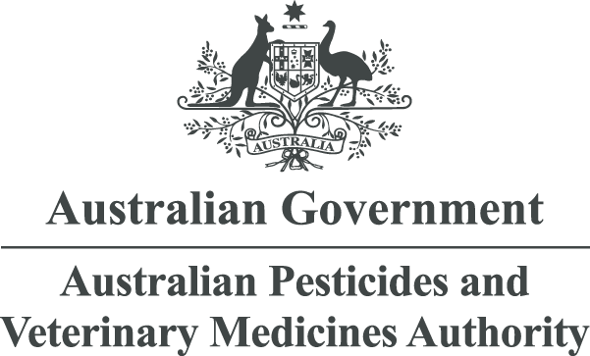



Trade Advice Notice

on sulfoxaflor for use on lentils

Emergency Permit 93834

August 2023

© Australian Pesticides and Veterinary Medicines Authority 2023

ISSN 2200-3894 (electronic)

**Ownership of intellectual property rights in this publication**

Unless otherwise noted, copyright (and any other intellectual property rights, if any) in this publication is owned by the Australian Pesticides and Veterinary Medicines Authority (APVMA).

**Creative Commons licence**

With the exception of the Coat of Arms and other elements specifically identified, this publication is licensed under a Creative Commons Attribution 4.0 Licence. This is a standard form agreement that allows you to copy, distribute, transmit and adapt this publication provided that you attribute the work.

Creative Commons logoAttribution Creative Commons Logo

A [summary of the licence terms](https://creativecommons.org/licenses/by/4.0/) and [full licence terms](https://creativecommons.org/licenses/by/4.0/legalcode) are available from Creative Commons.

The APVMA’s preference is that you attribute this publication (and any approved material sourced from it) using the following wording:

*Source: Licensed from the Australian Pesticides and Veterinary Medicines Authority (APVMA) under a Creative Commons Attribution 4.0 Australia Licence.*

In referencing this document the Australian Pesticides and Veterinary Medicines Authority should be cited as the author, publisher and copyright owner.

**Use of the Coat of Arms**

The terms under which the Coat of Arms can be used are set out on the [Department of the Prime Minister and Cabinet website](https://www.pmc.gov.au/honours-and-symbols/commonwealth-coat-arms).

**Disclaimer**

The material in or linking from this report may contain the views or recommendations of third parties. Third party material does not necessarily reflect the views of the APVMA, or indicate a commitment to a particular course of action. There may be links in this document that will transfer you to external websites. The APVMA does not have responsibility for these websites, nor does linking to or from this document constitute any form of endorsement. The APVMA is not responsible for any errors, omissions or matters of interpretation in any third-party information contained within this document.

**Comments and enquiries regarding copyright:**

Assistant Director, Communications  
Australian Pesticides and Veterinary Medicines Authority  
GPO Box 3262  
Sydney NSW 2001 Australia

Telephone: +61 2 6770 2300

Email: [communications@apvma.gov.au](mailto:communications@apvma.gov.au).

This publication is available from the [APVMA website](http://www.apvma.gov.au).

Contents

Preface 1

About this document 1

Making a submission 1

Further information 2

Introduction 3

Trade considerations 4

Commodities exported 4

Destination and value of exports 4

Proposed Australian use pattern 6

Withholding periods 6

Results from residues trials presented to the APVMA 6

Overseas registration and approved label instructions 7

Codex Alimentarius Commission and overseas MRLs 7

Current and proposed Australian MRLs for sulfoxaflor 9

Potential risk to trade 9

Conclusion 11

List of tables

Table 1: Proposed use pattern – Transform Isoclast active Insecticide (240 g/L sulfoxaflor) 6

Table 2: Current and proposed Australian and overseas MRLs/tolerances for sulfoxaflor. 8

Table 3: Current MRL Standard – Table 1 9

Table 4: Proposed MRL Standard – Table 1 9

Preface

The Australian Pesticides and Veterinary Medicines Authority (APVMA) is an independent statutory authority with responsibility for assessing and approving agricultural and veterinary chemical products prior to their sale and use in Australia.

The APVMA has a policy of encouraging openness and transparency in its activities and of seeking stakeholder involvement in decision making. Part of that process is the publication of Trade Advice Notices for all proposed extensions of use for existing products where there may be trade implications.

The information and technical data required by the APVMA to assess the safety of new chemical products and the methods of assessment must be undertaken according to accepted scientific principles. Details are outlined in regulatory guidance published on the APVMA website.

About this document

This Trade Advice Notice indicates that the APVMA is considering an application to vary the use of an existing registered agricultural or veterinary chemical.

It provides a summary of the APVMA’s residue and trade assessment.

Comment is sought from industry groups and stakeholders on the information contained within this document.

Making a submission

The APVMA invites any person to submit a relevant written submission as to whether the application for an emergency use permit for use of sulfoxaflor on lentils should be granted. Submissions should relate only to matters that the APVMA is required by legislation to take into account in deciding whether to grant the application. These grounds relate to the trade implications of the extended use of the product. Submissions should state the grounds on which they are based. Comments received outside these grounds cannot be considered by the APVMA.

Submissions must be received by the APVMA by close of business on Monday 28 August 2023 and be directed to the contact listed below. All submissions to the APVMA will be acknowledged in writing via email or by post.

Relevant comments will be taken into account by the APVMA in deciding whether to grant the application and in determining appropriate conditions of registration and product labelling.

When making a submission please include:

* contact name
* company or organisation name (if relevant)
* email or postal address (if available)
* the date you made the submission.

Please note: submissions will be published on the APVMA’s website, unless you have asked for the submission to remain confidential, or if the APVMA chooses at its discretion not to publish any submissions received (refer to the [public consultation coversheet](https://apvma.gov.au/node/72856)).

Please lodge your submission using the [public consultation coversheet](https://apvma.gov.au/node/72856), which provides options for how your submission will be published.

Note that all APVMA documents are subject to the access provisions of the *Freedom of Information Act 1982* and may be required to be released under that Act should a request for access be made.

Unless you request for your submission to remain confidential, the APVMA may release your submission to the applicant for comment.

Written submissions should be addressed to:

Executive Director, Risk Assessment Capability

Australian Pesticides and Veterinary Medicines Authority

GPO Box 3262

Sydney NSW 2001

**Phone:** +61 2 6770 2300

**Email:** [enquiries@apvma.gov.au](mailto:enquiries@apvma.gov.au).

Further information

Further information can be obtained via the contact details provided above.

Further information on Trade Advice Notices can be found on the APVMA website: [apvma.gov.au](http://www.apvma.gov.au).

# Introduction

The APVMA has before it an emergency permit application from Pulse Australia Pty Ltd for the use of sulfoxaflor on lentils.

The proposed emergency permit is for use in South Australia only for a period of 3 years (between July and November). It is estimated that up to 250,000 ha of lentils may be treated.

# Trade considerations

## Commodities exported

Pulses are considered to be major export commodities[1], as are commodities of animal origin such as meat, offal and dairy products which may be derived from livestock fed feeds produced from treated pulse forage and fodder. Residues in these commodities resulting from the use of sulfoxaflor may have the potential to unduly prejudice trade.

Whilst the proposed crop (lentils) is not specifically listed in the APVMA *Pesticides: Overseas trade (Part 5B)* guidelines, based on the significant value of exports of Australian lentils, particularly in the last few years, they are a major export commodity.

No changes are required to the current animal commodity MRLs for sulfoxaflor from the proposed use on lentils. Consistent with the registered uses on adzuki, mung and navy beans, a trade advice statement stipulating that ‘livestock that have been grazed on or fed treated crops should be placed on clean feed for 14 days prior to slaughter’ has been recommended to ensure that there are no detectable residues in animal commodities for export. With this recommendation, the risk to trade in animal commodities remains unchanged and does not require further consideration.

## Destination and value of exports

India and Bangladesh are the most significant markets with other markets in the Middle East and Asia including Sri Lanka, Türkiye, the United Arab Emirates, Egypt and Nepal also significant.

In 2021–22, Australia exported 4,618 kilotonnes (kt) of total pulses (worth $2.32 billion), 605 kt of chickpeas ($476 million), 460 kt of lupins (worth $231 million) and 223 kt of field peas (worth $123 million)[2]. Whilst the Australian Bureau of Agricultural and Resource Economics and Sciences (ABARES) does not report individual export data for lentils, the Australian Trade and Investment Commission (Austrade) has reported the values of Australian lentil exports over recent years based on Australian Bureau of Statistics (ABS)[3] data with lentil exports worth approximately $950 million in 2021–22.

A combination of the ABARES and ABS data has been used to generate the following plot shown in Figure 1.

Figure 1: Australian export values for pulses 2017–22

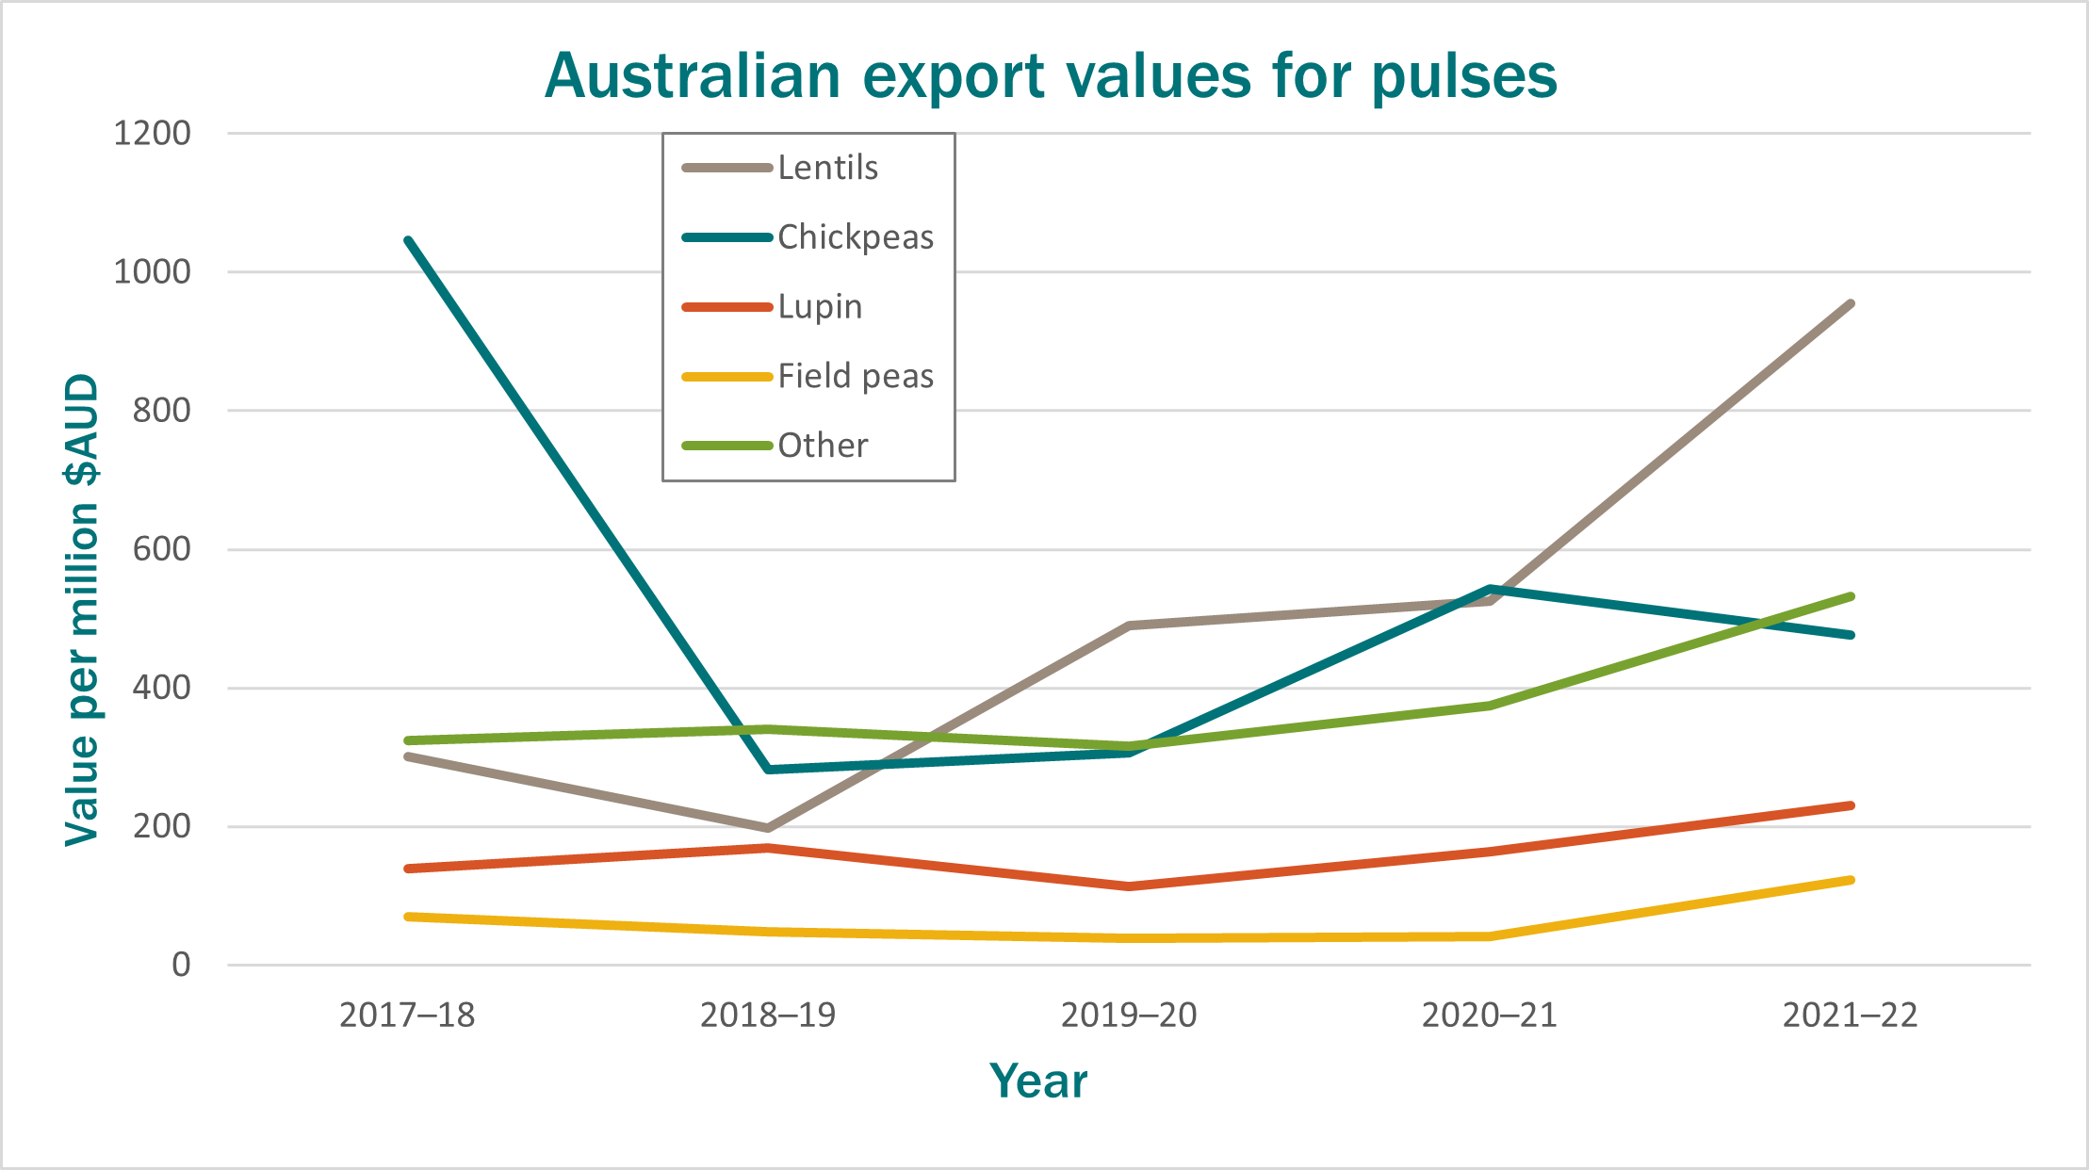

Australian exports of lentils continued at record pace through 2022–23. Between October 2022 and March 2023 Australia shipped 734 kt of lentils with 580 kt shipped between March and May 2023. In May 2023 alone, Australia exported a record 265 kt of lentils with 110 kt exported to India, followed by Türkiye (51 kt) and Nepal (28 kt). Between March and May 2023 the major markets continued to be India (236 kt), followed by Bangladesh (107 kt), Sri Lanka (54 kt), Türkiye (53 kt), the United Arab Emirates (42 kt), Egypt (37 kt) and Nepal (36 kt)[4].

## Proposed Australian use pattern

Table 1: Proposed use pattern – Transform Isoclast active Insecticide (240 g/L sulfoxaflor)

| Crop | Pest | Rate/concentration | Critical comments |
| --- | --- | --- | --- |
| Lentils | Blue green aphid *(Acyrthosiphon kondoi)*  Green peach aphid *(Myzus persicae)* | 100 mL/ha (24 g ai/ha) + Agral spray adjuvant at label rates | Apply as a foliar cover spray following first signs of pest infestation using a boomspray.  DO NOT apply more than 2 applications per crop with a minimum re-treatment interval of 14 days.  Ground spray volume: Minimum of 50 L/ha  Air spray volume: Minimum of 30 L/ha  DO NOT apply this product while bees are foraging in the crop to be treated.  Refer to the *Protection of honeybees* *and other insect pollinators* statement on the product label. |

### Withholding periods

#### Harvest

Do not harvest for 28 days after application.

#### Grazing

Do not graze or cut for stockfeed for 14 days after application.

## Results from residues trials presented to the APVMA

From a Trade Advice Notice (TAN)[5] related to the residues evaluation of the proposed use of Transform Insecticide and Expedite Full Insecticide on pulses (64101/104345 and 65464/104351).

The TAN noted:

*“Six new Australian trials on field peas, lentils and faba beans are supported by 19 previously submitted overseas trials on soybeans and six on dry beans.*

*Residues of sulfoxaflor in pulse grain at harvest 14* *days (or more) after the last of two applications at 24* *g* *ai/ha (1× proposed) were* *0.02, 0.04, 0.04, 0.06, 0.29 and 0.32* *mg/kg. The STMR is 0.05* *mg/kg. The OECD MRL calculator recommends an MRL of 0.7* *mg/kg.*

*In trials in the USA and Brazil residues of sulfoxaflor in soybeans at a seven-day harvest interval after four applications at 100* *g* *ai/ha (4× proposed) were: <0.01 (8), 0.01, 0.02 (3), 0.03 (2), 0.04 (3), 0.09, and 0.21 mg/kg.*

*In six trials on dry beans in Brazil, Germany and Spain, following four applications of sulfoxaflor at a total rate of 0.350–0.365* *lb a.i./A (~400* *g a.i./ha), residues of sulfoxaflor were 0.02, 0.05, 0.09, 0.09, 0.10 and 0.11* *mg/kg in/on dried beans harvested at a seven-day PHI.”*

The overseas trials are only supportive in nature given they involved more applications, higher application rates and shorter PHIs compared to the proposed GAP for lentils and are not considered suitable for MRL estimation for the proposed GAP.

The proposed use in lentils is similar to the registered use pattern in dried beans (adzuki beans, mung beans and navy beans only), except for a longer proposed harvest withholding period of 28 days.

Based on the available information relevant to the proposed use, a sulfoxaflor MRL of T0.7 mg/kg for [VD 0533] Lentils (dry) is recommended to cover sulfoxaflor residues arising in lentil grains as a result of the proposed use in conjunction with a harvest-withholding period of 28 days.

## Overseas registration and approved label instructions

The applicant indicated that there are overseas use patterns for dry beans (Subgroup 015A, Dry beans) but did not indicate overseas use patterns on lentils (Subgroup 015B, Dry peas).

## Codex Alimentarius Commission and overseas MRLs

The Codex Alimentarius Commission (Codex) is responsible for establishing Codex Maximum Residue Limits (CXLs) for pesticides and veterinary medicines. Codex CXLs are primarily intended to facilitate international trade and accommodate differences in Good Agricultural Practice (GAP) employed by various countries. Some countries may accept Codex CXLs when importing foods. Sulfoxaflor has been considered by Codex. The following relevant Codex CXLs have been established for sulfoxaflor.

Table : Current and proposed Australian and overseas MRLs/tolerances for sulfoxaflor.

| Commodity | Tolerance for residues arising from the use of sulfoxaflor (mg/kg) | | | | | |
| --- | --- | --- | --- | --- | --- | --- |
| Australia[6] | Codex[7] | China[8] | EU[9] | Korea[10] | USA[11] |
| Residue definition | Sulfoxaflor | Sulfoxaflor | Sulfoxaflor | Sulfoxaflor (sum of isomers) | Sulfoxaflor | Sulfoxaflor |
| Lentils | 0.7  Beans, dried (current)  T0.7  Lentils (dry)  (proposed) | 0.3 Beans (dry) | – | *0.01 Lentils  0.3 Beans | 0.2 Beans | 0.2 Bean, dry seed |

Note: There is no established MRL/tolerance for lentils in the Indian Food Safety and Standards (Contaminants, Toxins and Residues) Regulation, 2011[12]. The Regulation states that a tolerance limit of 0.01 mg/kg shall apply in cases of pesticides for which MRL have not been fixed.

## Current and proposed Australian MRLs for sulfoxaflor

Table 3: Current MRL Standard – Table 1

| Compound | Food | MRL (mg/kg) |
| --- | --- | --- |
| Sulfoxaflor | | |
| VD 0071 | Beans (dry) | 0.7 |
| VD 0523 | Broad bean (dry) | T0.7 |
| MO 0105 | Edible offal (mammalian) | 0.5 |
| PE 0112 | Eggs | *0.01 |
| MM 0095 | Meat (mammalian) | 0.2 |
| ML 0106 | Milks | 0.1 |
| PM 0110 | Poultry meat | *0.01 |
| PO 0111 | Poultry, edible offal of | *0.01 |
| VD 0541 | Soya bean (dry) | 0.3 |

Table : Proposed MRL Standard – Table 1

| Compound | Food | MRL (mg/kg) |
| --- | --- | --- |
| Sulfoxaflor | | |
| Add: | | |
| VD 0533 | Lentils (dry) | T0.7 |

## Potential risk to trade

Export of treated produce containing finite (measurable) residues of sulfoxaflor may pose a risk to Australian trade in situations where (i) no residue tolerance (import tolerance) is established in the importing country or (ii) where residues in Australian produce are likely to exceed a residue tolerance (import tolerance) established in the importing country.

The proposed emergency use of sulfoxaflor on lentils requires the establishment of a finite MRL at T0.7 mg/kg [HR= 0.32 mg/kg, STMR= 0.05 mg/kg] for [VD 0533] Lentil (dry) in conjunction with the proposed 28-day harvest withholding period. Whilst there is international coverage in some markets for dry beans (Subgroup 015A, Dry beans) these MRLs/tolerances do not cover lentils (a member of Subgroup 015B, Dry peas). There are no finite MRLs/tolerances established for dried peas or lentils in overseas markets.

The major export markets for Australian lentils are in Asia and the Middle East. It is noted that the 2 major markets for Australian lentils, India and Bangladesh maintain a national MRL list. India sets a default tolerance of 0.01 mg/kg for commodity/pesticide combinations for which a specific tolerance has not been established[13] whilst Bangladesh defers to Codex when a national MRL is not established and does not apply a default MRL[14]. Other major markets such as Egypt and the United Arab Emirates defer to EU MRLs in the absence of a relevant Codex MRL. In the absence of a finite Codex or EU MRL, a default MRL of 0.01 mg/kg applies[15].

Given the lack of international sulfoxaflor MRL coverage in most markets and the proposed Australian MRL for lentil at T0.7 mg/kg, comment is sought on the potential risk to Australian trade.

# Conclusion

Pulse Australia has applied for an emergency use permit for the use of sulfoxaflor on lentils.

Comment is sought on the potential for the proposed use to cause undue risk to the Australian trade of lentils and the ability of industry to manage any potential trade risk.

1. Australian Pesticides and Veterinary Medicines Authority (APVMA), 2020. [*APVMA Part 5B Residues Guidelines – Major export food commodity groups*](https://apvma.gov.au/node/1017), APVMA website, accessed 17 July 2023.
2. Department of Agriculture, Fisheries and Forestry (DAFF), 2023. [*Australian Bureau of Agricultural and Resource Economics and Sciences (ABARES) – Agricultural commodities and trade data – 2022*](https://www.agriculture.gov.au/abares/research-topics/agricultural-outlook/data#_2022), ABARES website, accessed 21 July 2023.
3. Australian Bureau of Statistics (ABS), n.d. [*Australian Bureau of Statistics (ABS)*](https://www.abs.gov.au/)*,* ABS website, accessed 21 July 2023.
4. Grain Central, 2023. [*Australia posts solid May chickpea, record lentil exports*](https://www.graincentral.com/markets/australia-posts-solid-may-chickpea-record-lentil-exports/), Grain Central website, accessed 21 July 2023.

   4Grain Central, 2023. [*Australia ships 53,448t chickpeas, 168,650t lentils in March*](https://www.graincentral.com/markets/australia-ships-53448t-chickpeas-168650t-lentils-in-march/), Grain Central website, accessed 21 July 2023.
5. Australian Pesticides and Veterinary Medicines Authority (APVMA), 2016. [*Trade Advice Notice on sulfoxaflor in the product Expedite Full Insecticide for use on almonds, pulses and sweet corn – APVMA product number 65464*](https://apvma.gov.au/node/20516), APVMA website, accessed 29 July 2023.
6. Australian Government Federal Register of Legislation, 2019. [*Agricultural and Veterinary Chemicals Code (MRL Standard) Instrument 2019*](https://www.legislation.gov.au/Details/F2022C01128), Federal Register of Legislation website, accessed 19 July 2023.
7. Food and Agriculture Organisation of the United Nations (FAO), 2023.[*Codex Alimentarius – International Food Standards*](https://www.fao.org/fao-who-codexalimentarius/codex-texts/dbs/pestres/pesticides/en/), FAO website, accessed 19 July 2023.
8. United States Department of Agriculture (USDA) Foreign Agricultural Service, 2021. [*People's Republic of China – USFDA, Translation of MRLs of Pesticides in Foods*](https://www.fas.usda.gov/data/china-translation-maximum-residue-limits-pesticides-foods), USDA website, accessed 19 July 2023.
9. European Commission, 2023. [*European Commission – Pesticide residue(s) and maximum residue levels (mg/kg)*](https://ec.europa.eu/food/plant/pesticides/eu-pesticides-database/start/screen/mrls/searchpr) European Commission website, accessed 19 July 2023.
10. Food Safety Korea, 2015. [*Food Safety Korea – Residue Information*](http://www.foodsafetykorea.go.kr/residue/prd/mrls/list.do?currentPageNo=3&searchCode=&searchFoodCode=&menuKey=1&subMenuKey=161&subChildMenuKey=&searchConsonantFlag=en&searchConsonantFlag2=en&searchValue2=D&searchFlag=prd&searchClassLCode=&searchClassMCode=&searchClassScode=&searchValue=D), FSK website, accessed 19 July 2021.
11. Electronic Code of Federal Regulations (eCFR), 2023. [*USA Electronic Code of Federal Regulations*](https://www.ecfr.gov/current/title-40/chapter-I/subchapter-E/part-180), eCFR website, accessed 19 July 2023.
12. Food Safety and Standards Authority of India (FSSAI). [*Food Safety and Standards (Contaminants, Toxins and Residues) Regulation, 2011*](https://fssai.gov.in/cms/food-safety-and-standards-regulations.php), FSSAI website, accessed 21 July 2023.
13. Northwest Horticultural Council, 2023. [India – Northwest Horticultural Council,](https://nwhort.org/export-manual/countries-toc/india/) nwhort.org website, accessed 19 July 2023.
14. Northwest Horticultural Council, 2023. [Bangladesh – Northwest Horticultural Council,](https://nwhort.org/export-manual/countries-toc/bangladesh/) nwhort.org website, accessed 19 July 2023.
15. Northwest Horticultural Council, 2023. [United Arab Emirates (UAE) – Northwest Horticultural Council](https://nwhort.org/export-manual/countries-toc/united-arab-emirates/), nwhort.org website, accessed 19 July 2023.