Trade Advice Notice on isocycloseram in the product Vertento Insecticide for use on citrus

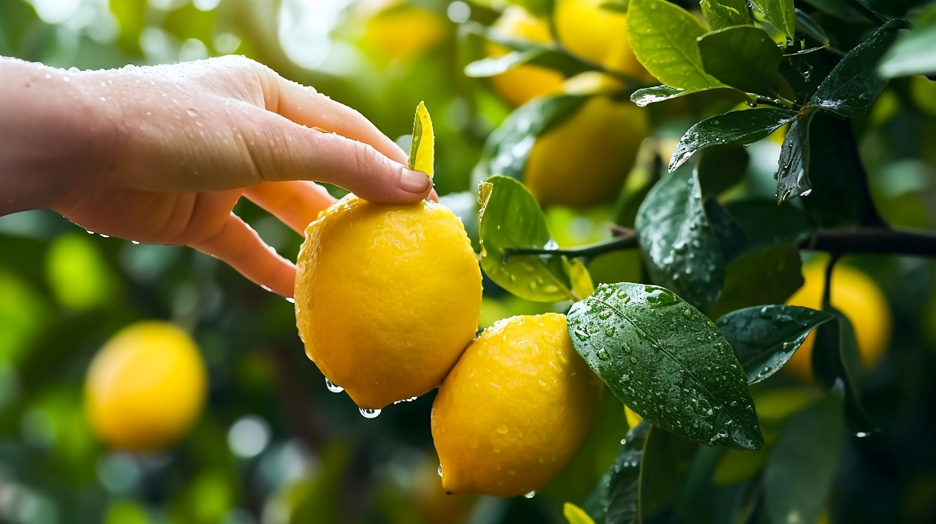#HaveYourSay – the #APVMA invites comment on the proposed use of isiocycloseram in the product Vertento Insecticide for use on citrus. Consultation closes 10 May 2024 www.apvma.gov.au/news-and-publications/public-consultations/tan-isocycloseram-in-the-product-vertento-insecticide