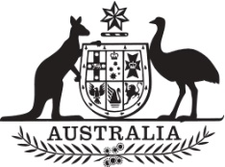

Commonwealth of Australia

Gazette

Agricultural and veterinary chemicals

APVMA Special Gazette, 15 July 2022

Published by the Australian Pesticides and Veterinary Medicines Authority

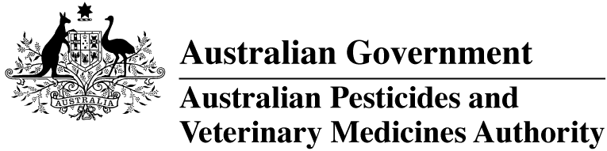

The *Agricultural and Veterinary Chemical Code Act 1994* (the Act) commenced on 15 March 1995. The Agricultural and Veterinary Chemicals Code (the Agvet Code) scheduled to the Act requires notices to be published in the *Gazette* containing details of the registration of agricultural and veterinary chemical products and other approvals granted by the Australian Pesticides and Veterinary Medicines Authority. The Agvet Code and related legislation also requires certain other notices to be published in the *Gazette*. A reference to Agvet Codes in this publication is a reference to the Agvet Code in each state and territory jurisdiction.

ISSN 1837-7629

© Commonwealth of Australia 2022

This work is copyright. Apart from any use as permitted under the *Copyright Act 1968*, no part may be reproduced by any process without prior written permission from the Australian Pesticides and Veterinary Medicines Authority (APVMA). Requests and inquiries concerning reproduction and rights should be addressed to:

Assistant Director, Communications  
Australian Pesticides and Veterinary Medicines Authority  
GPO Box 3262  
Sydney NSW 2001

Email: [communications@apvma.gov.au](mailto:communications@apvma.gov.au)  
Website: [apvma.gov.au](http://www.apvma.gov.au)

General information

The APVMA Gazette is published fortnightly and contains details of the registration of agricultural and veterinary chemicals products and other approvals granted by the APVMA, notices as required by the Agricultural and Veterinary Chemicals Code (the Agvet Code) and related legislation and a range of regulatory material issued by the APVMA.

Pursuant to section 8J(1) of the Agvet Code, the APVMA has decided that it is unnecessary to publish details of applications made for the purpose of notifying minor variations to registration details. The APVMA will however report notifications activity in quarterly statistical reports.

Distribution and subscription

The APVMA Gazette is published in electronic format only and is available from the [APVMA website](http://www.apvma.gov.au/news-and-publications/publications/gazette).

If you would like to subscribe to receive email notification when a new edition is published, please complete a [subscription form](https://apvma.us2.list-manage.com/subscribe?u=f09f7f9ed2a2867a19b99e2e4&id=a025640240).

APVMA contacts

For enquiries regarding the publishing and distribution of the APVMA Gazette: Telephone: +61 2 6770 2300.

For enquiries on APVMA Gazette content, please refer to the individual APVMA contacts listed under each notice.

Privacy

For information on how the APVMA manages personal information when you contact us, see our [Privacy Policy](https://apvma.gov.au/node/59876).

Contents

Amendments to the APVMA MRL Standard 1

Amendments to the APVMA MRL Standard

The Australian Pesticides and Veterinary Medicines Authority (APVMA) approves maximum residue limits (MRLs) of agricultural and veterinary chemicals in agricultural produce, particularly produce entering the food chain. The MRLs approved by the APVMA are associated with a regulatory decision to register a product, grant a permit approval, or as an outcome from a review decision and are set out in the Agricultural and Veterinary Chemicals Code (MRL Standard) Instrument 2019. The MRL Standard lists MRLs of substances that may arise from the approved use of agricultural and veterinary chemical products containing those substances on commodities used for human consumption as well as livestock feeds. The MRL Standard also provides the relevant residue definitions to which these MRLs apply. There may be situations where the residue definition for monitoring and enforcement is different to the definition used for dietary risk assessment purposes.

MRLs are set at levels which are not likely to be exceeded if the agricultural or veterinary chemicals are used in accordance with approved label instructions. In considering MRLs and variation to MRLs, the APVMA takes into account studies on chemistry, metabolism, analytical methodology, residues, toxicology, good agricultural practice and dietary exposure. In approving MRLs, the APVMA is satisfied, from dietary exposure assessment, that the levels set are not an undue hazard to human health.

The APVMA has amended the MRL Standard, and the changes will have affect the day after the instrument is registered.

Details of the amendment can be found in the Agricultural and Veterinary Chemicals Code (MRL Standard) Amendment Instrument (No. 5) 2022.

The amendments will be incorporated into the compilation of the Agricultural and Veterinary Chemicals Code (MRL Standard) Instrument 2019.

The MRL Standard is accessible via the [Federal Register of Legislation website.](https://www.legislation.gov.au/Series/F2019L01105)

For further information please contact:

MRL Contact Officer

Australian Pesticides and Veterinary Medicines Authority

GPO Box 3262

Sydney NSW 2001

**Phone:** +61 2 6770 2300

**Email:** [enquiries@apvma.gov.au](mailto:enquiries@apvma.gov.au)