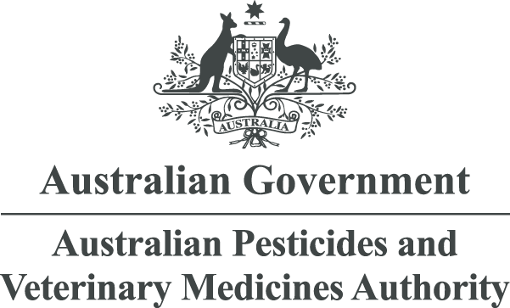

Application guidance and FAQs
Step up your career with a world-class regulator
Application guidance
Thank you for your interest in employment at the Australian Pesticides and Veterinary Medicines Authority (APVMA). If one of the opportunities we have advertised looks like it is right for you, please consider the following information when drafting your application.
Responses to the selection criteria
Excluding the APVMA’s temporary employment register, most of our vacancies require you to write a response to the selection criteria as part of your application. In drafting this document, you will need to respond to each criterion by explaining how you have demonstrated the skill or quality the criteria have specified. Responses should be clear and to the point, honest, specific and stick to the word limit.
To do this, it is important to provide evidence to back up your claims by using relevant examples from your work, study, or community roles. These are best framed by following the STAR method:
- Situation: Set the context by describing the circumstance.
- Task: What was your role or responsibility?
- Actions: What did you do and how did you do it?
- Results: What did you achieve? What was the end result and how does it relate to the job you are applying for?
An example is provided below:
As Policy Support Officer at the ABC Agency, I was tasked with ensuring that senior managers were kept informed of policy changes resulting from the agency’s XYZ project. To do this I instigated a monthly newsletter, which was circulated to each manager. I took responsibility for writing the main articles in each publication. This involved obtaining ideas and input from other stakeholders to ensure that the articles reflected the needs of managers, both in terms of content and language. I received a CEO citation award for the quality of the newsletter, as well as consistently excellent feedback from internal stakeholders and my own manager. The initiative resulted in improved lines of communication between managers and the Policy Unit and was noted as one of the unit’s key achievements for the 2021 calendar year.
Resume
We would recommend considering the following when tailoring your resume:
- Consistent formatting
- Easy to read
- Concise
- Use real examples – avoid general statements
- Check your resume for relevance, typos, and flow
Your resume will vary in length depending on your experience and education. Make sure you include your employment history in chronological order, including the duties and responsibilities for each role. Your resume should also include key skills and strengths, technical or software skills, educational qualifications, awards and training courses. Keeping your resume factual, brief and easy to read makes it easier for the panel to focus on key facets of your work history and experience.
Frequently asked questions
What other assessments will I have to undertake?
Your application will be assessed on your ability to demonstrate that you can perform in the role. If your application is shortlisted, you will be progressed to the second phase of our assessment process. We may use a variety of techniques to assess candidates, such as:
- interviews (formal and informal)
- work sample tests
- psychometric testing
- reference checks.
How many referees do I need to nominate?
In most instances, the APVMA will require the names and contact information of at least 2 referees, one of which should be your current direct supervisor.
What is a merit pool?
Candidates who are found suitable but not successful are placed into an APVMA merit pool. Merit pools can be used to offer you employment to similar positions up to 18 months after the date the vacancy was advertised.
Offers of employment are made on a case-by-case basis and at the APVMA’s discretion.
What is a security clearance?
Under the Australian Government Protective Security Policy Framework, all personnel within the Australian Public Service (APS) must hold a valid security clearance. If successful, you will be required to undergo the process of obtaining and maintaining a security clearance for the role. This is not required at the APVMA until after your commencement.
What if I require reasonable adjustments made to the application process?
We participate in the APS RecruitAbility Scheme to attract applicants with disability by removing some of the barriers in recruitment and employment processes. More information about the scheme is available on the Australian Public Service Commission website.
Who do I contact with questions?
For all queries about current vacancies and how to apply, please contact the APVMA People and Culture Team on +61 2 6770 2404 or HR@apvma.gov.au.

