

APVMA Screening Level
Risk Assessment Tool

Final Report

December 24th, 2015

M. Burgman, A. Hanea, A. Bartholomaeus

Contents
Executive Summary 3
1. Background 4
1.1 Screening Level Risk Assessment Tool Project Background 5
1.2 Project Stages 6
1.3 Principles 7
1.4 Where screening level risk assessment is used 9
1.5 Dealing with uncertainty 11
2. The APVMA Risk Screening System 13
2.1 Criteria 13
2.2 Background to the decision tree 14
2.3 Consultation and development of the decision tree 14
2.4 Decision tree logic 15
2.5 Feedback 22
3. Discussion 24
3.1 Turnaround times 24
3.2 Data requirements and costs 24
3.3 Standard Development 25
4. References 26
Appendix 1: Hypothetical Examples 28
Appendix 2: Glossary 30
Appendix 3: Additional figure 40

Executive Summary
This report outlines the development and testing of a screening level risk assessment tool for Australian agricultural chemicals and veterinary medicines, on behalf of the APVMA. It is framed around comparative risk assessment against reference products that have been assessed and approved previously, and encapsulates the procedures that are currently in place in the APVMA.
The tool is based on a decision tree that aggregates information on a range of factors relevant to applications for approval, registration and variation. It provides a platform that could be implemented in an on-line form, for applicants to provide rapid self-assessments of products requiring low regulatory intervention. It also provides a framework to allow the system to develop relatively easily as evidence of the safety of groups of products accumulates over time.
It will ensure consistent decision-making, given reliable inputs, and will be supported by a more vigorous surveillance and auditing system that encourages compliance and rewards routinely compliant applicants with reduced regulatory oversight. It will also have the impact of reducing the time it currently takes for new products to enter the market by eliminating those applications that can be managed with limited input from the APVMA.

1. Background
The Australian Pesticides and Veterinary Medicines Authority (APVMA) is the Australian Government regulator of agricultural and veterinary (agvet) chemical products. Agricultural and veterinary chemicals regulated by the APVMA are used by farmers, pest controllers, veterinarians, other professionals and home users, and include:
- agricultural chemicals such as pesticides, herbicides, biocides, insecticides and seed treatments
- veterinary chemicals such as medicines, antibiotics, hormonal treatments and some stock-feeds and pet foods, and
- other chemicals such as insect repellents, garden sprays and pool chemicals.
The APVMA regulates these chemical products up to and including the point of retail sale. Once a product is registered, it is approved for the purposes and uses stated on the product’s label.
The APVMA’s legislative framework provides for the protection of the health and safety of human beings, animals and the environment. The registration process involves a scientific evaluation of the safety and efficacy (effectiveness) of a product to protect the health and safety of people, animals, plants and the environment.
Expectations on the APVMA are that in fulfilling their duties in this regards their actions are consistent, efficient and transparent and that the level of regulatory intervention is aligned with the risks associated with the active constituent or product. The system for regulating chemical products and their constituents should be cost effective, efficient, predictable, adaptive and responsive. The APVMA must maintain a balance between regulatory effort, the regulatory burden imposed on those affected, and the risks associated with chemical use. In administering the code, the APVMA aims to ensure regulatory compliance in keeping with what is reasonably necessary to manage risks to the health and safety of human beings, animals, plants and the environment.
The legislative framework provides the APVMA with certain discretions—such as the extent to which it needs to take into account particular matters in determining whether safety, efficacy, trade and labelling criteria have been met. Applications are made to the APVMA to approve, register or vary active constituents, products, or labels. When making regulatory decisions, the APVMA must address all of the statutory criteria including safety, efficacy, trade and labelling. An application must be supported by information that allows the regulator to determine whether the product meets the applicable statutory criteria.
Different product types give rise to different risks and, as a result, the levels and types of assessment required to satisfy the statutory criteria in registering a new product vary. Generally, lower risk products require reduced levels of assessment and this is achieved through the use of categories of application graduated based on level of risk. However even for those applications where the risks are well understood, some regulatory effort and consideration is given before that application can be finalised.
Once an active constituent, label or agvet chemical product is approved, the relevant particulars or conditions may be changed through a process known as variations. Variations to products include adding new crops, animal species, use situations or instructions for use to the label, amending the site/s of manufacture, making changes to the formulation and adding new pack sizes. Although all of the statutory criteria are considered in the assessment of a variation application, applicants will usually only need to provide information that addresses the nature of the variation and whether the product, constituent or label meets all statutory criteria.
The APVMA also manages potential risks posed by agvet chemicals by, among other things, imposing conditions on approvals or registrations and by requiring that certain information be contained on product labels.

1.1 Screening Level Risk Assessment Tool Project Background
Screening-level risk assessment (sometimes referred to as Tier 0, Tier 1 or Level 1 risk assessment) refers to procedures that identify hazards that are clearly below a threshold of regulatory concern. These hazards can usually be dealt with quickly and efficiently without detailed scientific analysis or modelling based on existing knowledge through previous assessments. Many of the procedures outlined above implement screening-level risk assessments, especially those new registrations or approvals that are assessed relative to a reference product.
Screening level risk assessments are not designed nor intended to provide definitive estimates of actual risk or to identify risk management goals. Rather, they assess the need to conduct detailed assessments. The purpose of this report is to present a comprehensive, explicit tool for screening level risk assessments suitable for the regulatory context managed by the APVMA. The tool captures and formalizes the principles of screening-level risk assessment espoused in existing protocols and provides a platform for future refinement and development.

1.2 Project Stages
This project followed a review of the APVMA in 2013 to investigate what the APVMA needed to do to become a world-class regulator of agricultural and veterinary products. One of the recommendations arising from this review was that the APVMA develop a risk assessment framework in which lighter touch approaches to the regulation of agricultural and veterinary chemicals was possible. To achieve this, CEBRA was engaged to develop a risk assessment framework for the APVMA.
The contract commenced in March 2014. The following key activities were undertaken as part of this project.
Investigation stage
- Review / summary of existing APVMA criteria and principles for risk assessment
- Review and workshop report: the review will include existing and potential future regulatory and legal contexts, including potential for conditional registration, repeated items, and after care plans. The workshop will involve a foresight exercise, to evaluate and fully explore the characteristics of future regulatory environments.
- Report detailing the compilation, analysis and interpretation of data on adverse experiences.
- Review of procedures and models used in other jurisdictions and elsewhere globally to assess risks of equivalent products. The report will identify principles and criteria, assess strengths and weaknesses of these methods, and illustrate them with case studies and examples of potential advantages, inconsistencies and other flaws. Consultations should include international and local regulators and industry people.
- Review of emerging tools and methods for assessing equivalent risks. The report explores new approaches from mathematics and statistics, psychology, decision theory and computer science and will assess strengths and weaknesses of new methods for application to APVMA contexts, illustrated by case studies and examples of potential advantages, inconsistencies and other flaws.
Development stage
- Provide the APVMA with a report outlining principles and criteria for a new APVMA system. The report will describe the system with respect to the decision making underpinning it. It will include examples that illustrate its application to the range of contexts relevant to APVMA’s operation.
- Road Tests: develop a range of scenarios from case studies and internal advice, and trial them on experienced and in-experienced assessors and proponents to evaluate transparency, robustness and effectiveness.
Delivery stage
- Final report outlining a new system for APVMA. The report will account for external peer review comments from industry representatives. It will include recommendations for post-market verification for human health and the environment where possible, and random audit of applicant claims. The report will also identify critical gaps which if addressed, could enhance the proposed system.
This report is the final report for the project.

1.3 Principles
In the development of the Risk Assessment tool we examined relevant literature on the theory and applications of screening level risk assessments in relevant contexts elsewhere and evaluated their applicability, to the APVMA’s regulatory environment.
Traditional complete risk assessments, by their very nature, are:
- Comprehensive (identify and analyse all potential hazards).
- Flexible (applicable to all types of products).
- Transparent and repeatable (clear about the methods, data and assumptions used in the analyses).
- Cost effective (make use of existing knowledge within realistic time and resource limits).
- Scientifically defensible.
- Able to be tested (provide opportunities to monitor decisions and validate assessments with independent data).

Screening level risk assessments do not avoid these principles or short-cut scientific rigour. Rather, they satisfy these principles in a condensed form by making precautionary (risk averse) assumptions and estimates, or by making better use of the information and experience that the APVMA has gained over the years. An analyst may reach one of three endpoints:
- There are adequate data to conclude that risks are negligible, or are consistent with previous decisions to allow the product, and therefore there is no need for further assessment.
- The information is not adequate to make a decision. More information is required before a determination can be made.
- The information indicates the potential for adverse, unacceptable events and a more thorough assessment is warranted.

Screening level risk assessments assume the initial assessments are made within a hierarchy of more detailed analyses. The level of analysis depends on the outcome of the initial assessment. In general, the precautionary assessment of uncertainty results in more false positives (products identified as higher risk than would occur if assessed with more data) than false negatives (products scored as a lower risk than would occur when assessed with more data). This bias is important because false positive results can be screened out at higher levels in the risk analysis hierarchy. If the result of a conservative assessment is consistent with the regulator’s interpretation of acceptable risk, analysts can be confident that more detailed analysis would not change the decision to allow a product.
If the assessment results in uncertain outcomes or identifies potential problems (2 or 3 above), more complex analyses should follow with higher levels of risk assessments that aim to estimate the true values for parameters and their associated uncertainties.
Risk ranking refers to procedures that order hazards from higher to lower risk, without necessarily considering the absolute value of the risk associated with each hazard. Risk ranking can also be achieved by comparing the hazards and exposures of a product with those of products already approved or accepted by society. If the risks are equal to or less than those already accepted, the product may be deemed safe. The APVMA’s reference product approach is a risk ranking protocol.

1.4 Where screening level risk assessment is used
Apart from the APVMA, screening level risk assessments are used routinely in many disciplines and regulatory contexts including fisheries management, public health, biotechnology, hazardous waste management and chemical fate and effects assessments both within Australia and internationally.
The Therapeutic Goods Administration (TGA), for example, applies a risk based approach to the regulation of therapeutic goods including medicines that are available to the public without prescription. For these medicines the TGA applies five risk levels for new products, and for changes to an existing medicine four risk levels are applied. Data requirements and evaluation time lines are determined by the risk categorization. For example, ‘clones’ are assigned to the lowest risk category. They include products that are identical in all safety and efficacy respects to an existing fully evaluated medicine and for which the parent product has been fully evaluated for safety, efficacy and quality. Low risk medicines contain only ingredients that have been pre-approved below applicable concentration limits, for the applicable route of administration, and which make only limited, largely predefined, therapeutic claims. Some minor, low risk, variations are self-assessable by the sponsor of the goods. Examples of self-assessable variations include changes to; the manufacturing site for an active ingredient, assay and test methods, narrowing the limits for purity of actives or excipients, packaging materials and pack sizes, and some shelf life variations. In contrast, registered medicines are higher risk and require rigorous evaluation of quality, safety and efficacy of each product individually. Sponsors are required to provide comprehensive data sets to support these evaluations.
Unlike the TGA and the APVMA, FSANZ does not assess, approve or record the details of individual food products. Safety of food products is regulated through establishment of standards to which food products presented for sale in Australia must comply. Manufacturers and importers of food products self-assess the compliance of their products against the requirements of the Food Standards Code (the Code). Random audits of food products presented for sale, and at the border for food products imported into Australia, is the main mechanism for ensuring compliance. Where a manufacturer or importer wishes to sell a product that contains unapproved food additives or other unapproved regulated ingredients or is otherwise non-compliant with compositional standards for specific food types, then they are required to make an application to FSANZ to alter the Code. Within the FSANZ regulatory framework, risk stratification of applications or emerging food safety issues is primarily achieved through a combination of risk proportionate data requirements, and recognition of international evaluations where available.
Under NICNAS, industrial chemicals are categorized for regulatory purposes primarily on the basis of the exposure or hazard components of risk. The lowest level of regulatory activity is accorded to chemicals which are exempt from notification, but will generally require annual reporting, because they are, for example, polymers with chemical characteristics consistent with low to negligible potential human health and eco-toxicity hazards. Such notifications do not generally require toxicology or ecotoxicology studies, although summaries of any available studies would be expected to be provided.
US EPA provisions make ‘minimum risk’ pesticides exempt from federal registration. To qualify as a minimum risk pesticide, all five of the following criteria must be met:
- The product must contain only exempted active ingredients
- The product must contain only “Inert Ingredients of Minimal Concern”
- All active and inert ingredients must be listed on the label.
- The label cannot claim that minimum risk pesticides protect human or public health nor include any false or misleading statements.
- The label cannot include public health claims.
The US EPA’s Air Toxics Risk Assessment Technical Resource Manual advocates a three-tiered risk assessment process whereby each successive tier represents more complete characterization of variability and uncertainty as well as a corresponding increase in complexity and resource requirements. In this scheme, Tier 1 is represented as a relatively simple screening-level analysis using conservative and/or default exposure assumptions.
One of the most influential screening level risk assessments for chemicals was developed by Kroes and colleagues in 2004 for human diets and suggested that screening level assessments are appropriate for low molecular weight compounds for which limited toxicity data are available. More generally, the Threshold of Toxicological Concern (TTC) concept refers to generic oral exposure levels for (groups of) chemicals below which there is expected to be no appreciable risk to human health, a screening tool for chemicals for which specific toxicity data are not available. Originally proposed for food additives and flavourings, it has been investigated and proposed for use in a wide range of regulatory areas. Screening approaches are also used by the European chemicals regulator, REACH (for the Registration, Evaluation, Authorisation and Restriction of Chemicals), and for dietary exposure assessment by the European Food Safety Authority.
The complexity of the APVMA as an organisation, specifically the number of areas that it must consider in its decision-making and the interactions between these areas mean that the development of a simple tool is challenging. Although other regulators employ various tools to identify low risk products, they often are only considering one or two risk areas. In this respect a ‘one size fits all’ approach is not possible.

1.5 Dealing with uncertainty
Sound risk screening procedures embody risk-averse judgements, from the perspective of harm to human health and the environment. As noted above, screening level risk assessments may still occasionally result in the approval of products that would otherwise have been prohibited, if more information were available. Such ‘false negative’ assessments, while perhaps rare in a suitably risk averse system, may be compounded when comparative risk assessments have used them as a benchmark.
The best way to deal with uncertainty is to make a conservative initial assessment to avoid unintended damage to the economy, human health and the environment, and then accumulate independent empirical evidence of the exposures and effects of the product in question. Comparative risk assessments together with feedback from passive surveillance and targeted audits (see below) provide a reliable, risk-averse and transparent means for assessing new products. This is the basis for the approach that we develop below.
In some regulatory settings, safety (or uncertainty or adjustment) factors are routinely used in the estimation of acceptable exposures or concentrations in a range of chemicals regulatory fields especially when a chemical has been tested on model organisms under standardized conditions and regulators need to extrapolate the results. Safety factors are essentially arbitrary and may be difficult to justify, particularly if they entrain unintended risks by denying access to efficacious products. They will not play a part in the methods outlined below.
Some regulators consider costs and benefits of decisions, depending on context. However, explicit cost-benefit analysis for individual products or substances cannot be considered in the APVMA’s regulatory environment. As for all regulators in Australia a cost benefit analysis of changes to regulation is mandatory however.
Currently, the APVMA receives more than 3000 applications each year. A large number (about 70%) are to ‘image’ an existing pesticide or veterinary medicine or to vary an existing product. That is, an analyst can rely on the previous performance of the reference product in the market place to assess the potential for harm of many new proposals. Our objective is to capture the reasoning behind these comparative risk assessments in a form that satisfies the principles of effective risk assessment. That is, the approach we outline below will ensure screening level risk assessments conducted by the APVMA are comprehensive, flexible, transparent, repeatable, cost effective and scientifically defensible. The flexibility of the proposed model refers not only to its applicability to all types of products but also to its ability to represent, and manage different sources of uncertainty. More details about potential uncertainty modelling are given in the next section.

2. The APVMA Risk Screening System
The objective of this project is to create an automated system of self-assessment for applications that has the ability to readily identify applications requiring a low level of regulatory intervention. This system will have the capacity to replicate the logic deployed by the APVMA in its preliminary decision making, to decide whether an application can be approved without detailed intervention, oversight or assessment from government regulators.

2.1 Criteria
The APVMA’s regulatory environment is characterized by a large number of proposals (applications) that involve familiar and well-established levels of acceptable risk. Based on the review above, in APVMA’s screening level risk assessments, analysts could make use of comparative risk judgements in an automated approach to assessments. That is, in general, screening level risk assessments may be achieved for many products simply by establishing that they are less risky, in terms of likelihoods or the consequences of effects, than products that have already been approved and as such satisfy the safety criteria.
The following criteria are elements of the applications received by the APVMA that are used to guide comparative risk assessments.
- Actives
- Non-actives
- Concentrations
- Formula
- Label and label-like variations
- Host – Target Species
- Manufacturer
- Pack size and type
- Method of Application / Dose Administration
- Support/Ownership/Protected data

A subset of the above criteria will help define the application risk profile, which together with the support needed will determine the necessary regulatory input. In turn, the regulatory input together with the status of the active and non-active ingredients will play a direct role in the decision about the type of assessment needed for each application.

2.2 Background to the decision tree
The criteria that contribute to a decision need to be linked in a way that assimilates information coherently and provides an overall assessment of risk or relative risk. Decision trees are a flexible tool for linking evidence with regulatory thresholds and processes. They have a long and effective record in chemical safety management. For example, the first such application used decision trees to assess oral toxicity of food additives by evaluating how chemical structures were metabolised in mammalian metabolic pathways, accounting for natural occurrence in the body and in food. This approach has been extended and revised to account for new knowledge regarding structure-activity relationships and to incorporate different thresholds of toxicological concern for compounds with different structural characteristics.
We use a decision tree (formally, a Bayesian Network) to implement the comparative risk framework outlined above. The nodes in the tree reflect the criteria used currently by the APVMA to assess applications and identify which may be considered of low regulatory concern. The states of the nodes reflect the possible conditions under each node. Contingency tables at each node incorporate the logic that links the information provided by applicants to a determination for each criterion. The criteria are then combined into an overall decision. The nodes of a decision tree (or of a Bayesian network) need not be deterministic since they can be affected by various sources of uncertainty. Moreover, the available information may be linked through a probabilistic mechanism rather than a logical one. In this way, decision trees can assemble disparate information in a consistent and coherent framework while incorporating the unavoidable uncertainties. Even though the proposed decision tree is fully deterministic, its extension to incorporate uncertainty is straightforward.

2.3 Consultation and development of the decision tree
Workshops were held in Canberra at APVMA on 19 August 2015 (20 APVMA staff) and 23 September 2015 (APVMA staff and 14 industry representatives). The participants provided hypothetical examples (scenarios) of proposals and trialed their fate in the decision tree. The discussion sprung from the careful examination of these scenarios and covered more general (administrative) issues as well as detailed scientific issues about the structure of the decision tree.
Some of the administrative issues discussed and clarified included data protection and confidential commercial information CCI, the possibility to carry any data associated with a reference product over to a new product, and the benefits of generating approved lists (of ingredients/constituents) versus reliance on lists created by other agencies.
For applications requiring support from a parent company, a validation step was suggested, i.e. the person or organization from whom the support is needed should validate the claim of support made by the applicant, prior to the application being finalised through the online self-assessment tool.
The meanings and definitions of the criteria outlined in Section 2.1 were refined during the workshops. A consistent and application specific (agricultural vs. veterinary) terminology was proposed and adopted (e.g. the criterion Host/Target for the agricultural applications should correspond to Disease/Condition for the veterinary applications). The same distinction was considered necessary when defining criteria for veterinary vs. agricultural products. For example the “Method of Application” criterion was proposed to be defined in terms of timing, rate, frequency for agricultural products, and in terms of dose, frequency, duration, treatment interval, for veterinary products. A clear distinction between options/choices that define an application (e.g. the ingredients of a new product being on a low risk ingredients list), but are not currently available, and options available was considered necessary.
The discussion led to a range of structural changes of the decision tree (e.g. adding criteria/nodes in the tree), and revisions of the definitions of terms in the tree. Participants recommended the development of a careful, detailed glossary to explain the meaning of all terms in each node of the decision tree. This glossary can be found in Appendix 2.

2.4 Decision tree logic
The primary focus of the tree is on the decision to allow on-line approval (i.e., self-assessment) where the level of regulatory input necessary for that application has been determined to be ‘Low Category A’, or whether the proposal needs either a desktop of a full assessment (this is summarized in the node “Decision” from the bottom of Figure 1). In this case the level of regulatory input applicable, based on the characteristics of the application and associated use patterns is either Low Category B or Medium Category C, as described in Figure 1.

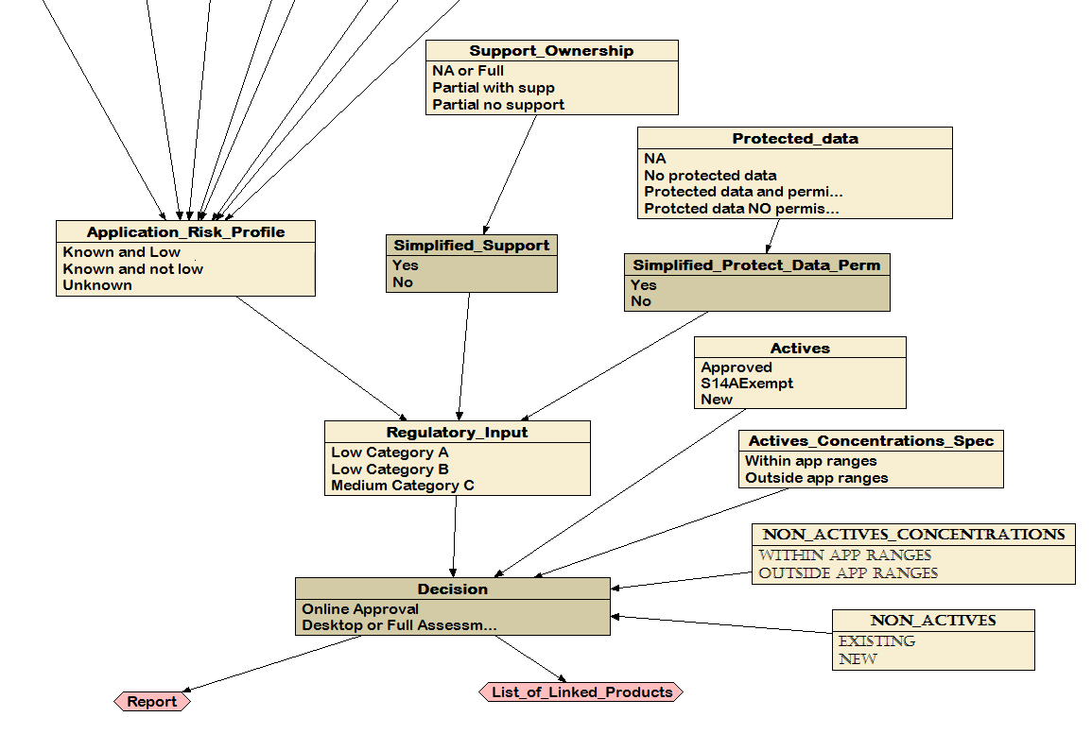
Figure 1. The decision node for determination of low risk applications. This node is determined by the status of active and non-active ingredients, by the support the application has from owners of the product and protected data, and by the level of regulatory input required.
At this stage, the tool does not discriminate between alternative forms of desktop assessment. It is limited to determining whether the proposal can be approved on-line, or not. Developments in the future will be able to make use of more detailed information to determine the level of desktop assessment a proposal may require. However, at this time that capability has not been implemented in the system described here.
The “Decision” node is directly influenced by five factors depicted as nodes in Figure 1: the “Regulatory Input” (discussed above), the “Actives” and their concentrations and specifications (Actives_Concentrations_specifications”) and the “Non Actives” and their concentrations (“Non_Actives_concentrations”). The status of the actives in the proposal depends on whether they are approved or exempt under S14A. In addition, the concentrations of actives need to be within specified ranges. Non-actives may be appropriate for on-line approval if they have been approved previously (‘existing’) and are within approved ranges. In general, an application with a low category A regulatory input will undergo online approval only when the actives and non actives are approved (or exempt) and within approved concentration ranges.
Each node is associated with a ‘contingency table’ that describes the relationships between the inputs and outputs of the node. For the ‘Regulatory Input’ node in Figure 1, the three ‘parent’ nodes require information about the application’s risk profile, and whether the application has the support of the product’s owner, and has permission to use protected data. These inputs are combined through the contingency table shown in Figure 2. The outcome of this node can be one of three states, Low (Category A), Low (Category B) or Medium (Category C). As mentioned above, only Low (Category A) can lead to an automated self-assessment.
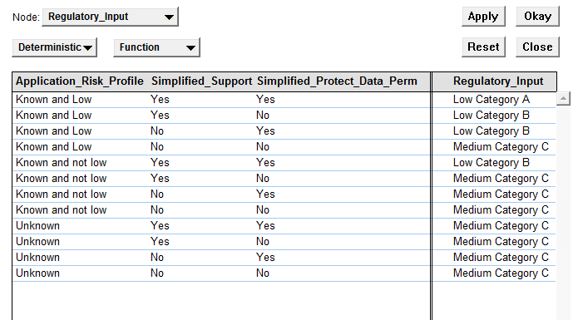
Figure 2. Contingency Table for the Regulatory Input Node.
The risk profile of the application is determined by the criteria below, with slight variations depending on whether the application is for a veterinary product or an agricultural product. The criteria are:
- Label variations
- Formulation
- Product
- Intended pest (Agricultural)
- Intended host (Agricultural)
- Disease/Condition (Veterinary)
- Animal/Commodity (Veterinary)
- Dose/Administration (Veterinary)
- Method of application(Agricultural)
- Shelf life (Veterinary)
- Manufacturer
- Pack size and type
Each of these criteria has several states. The “Label variations” node, for instance, has 7 states - N/A, no change, new label new product meets standard, notifiable variation, new label identical product, new label registered product, new label new product - but they simplify to one of three conditions; ‘none or not-applicable’, ‘allowed variations’ or ‘new’ (Figure 3 Agricultural products and Figure 4 Veterinary products). Likewise, the multiple states in most other nodes simplify to a smaller number that determine the approval outcome.
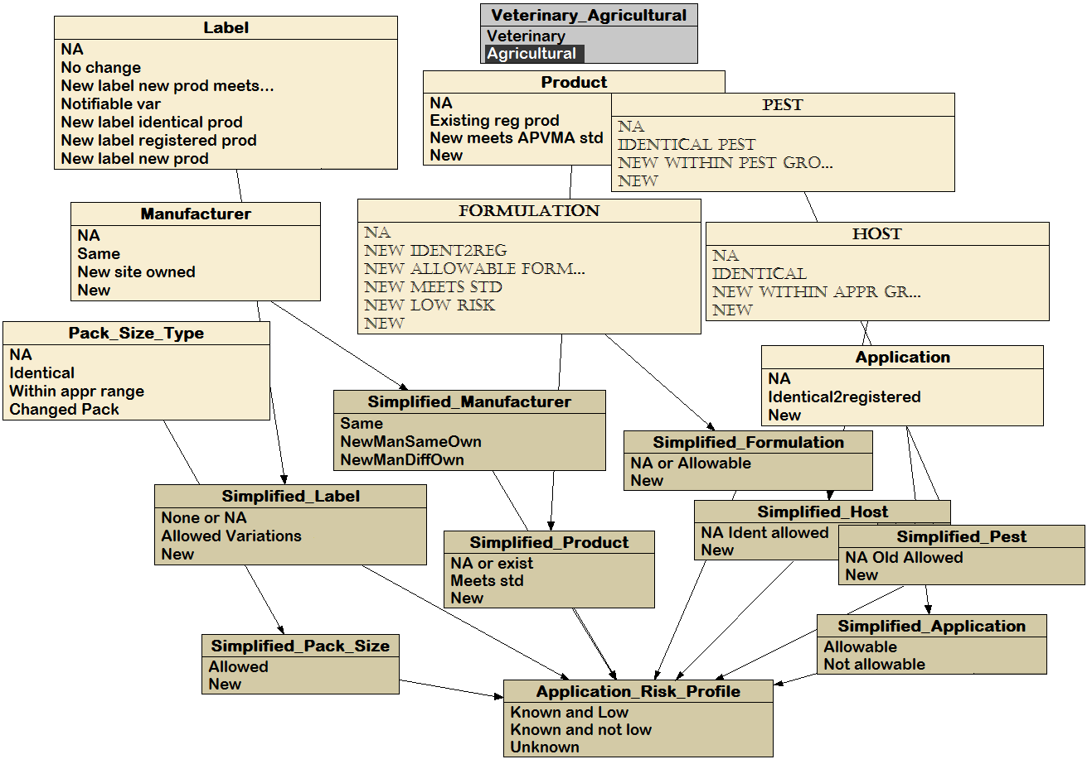
Figure 3. Details of the states that contribute to the determination of the risk profile or an application for approval of an agricultural chemical.

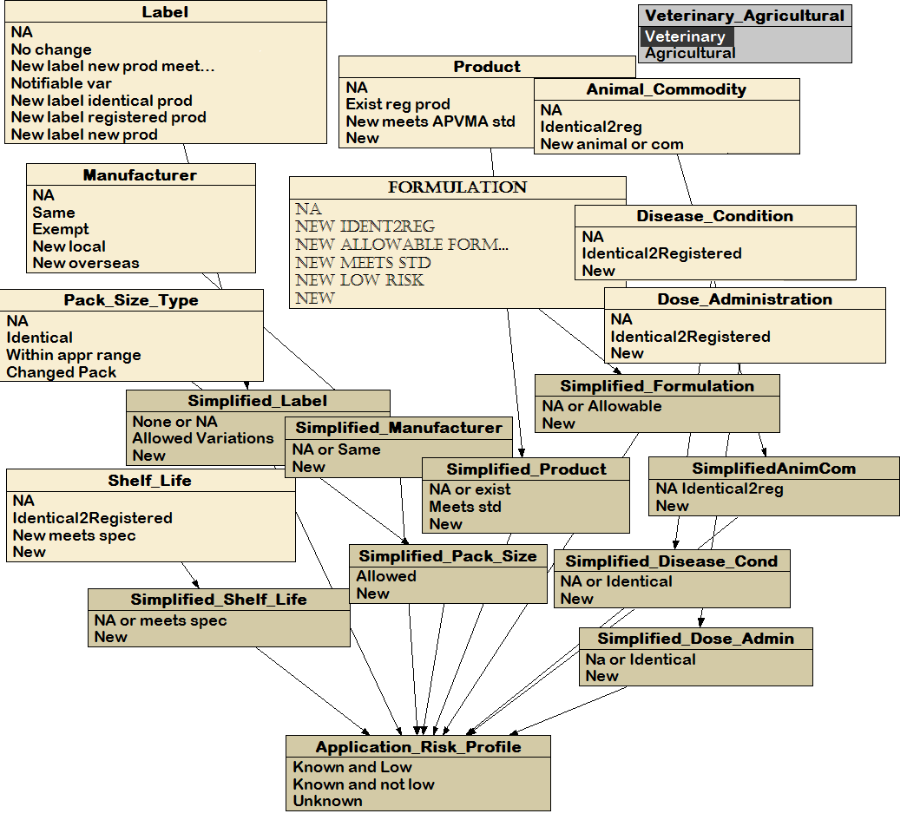
Figure 4. Details of the states that contribute to the determination of the risk profile for an application for approval of a veterinary medicine.
All states are meant to capture various degrees of detail about each particular application. Nevertheless the coarser classification will suffice for deciding between the approval being online or not. A very brief description of the above criteria follows here. For details we refer to Figure 5 and the glossary from Appendix 1.
The “Formulation” node distinguishes between an existing formulation used in a registered product, an allowable variation of an existing formulation or a completely new proposed formulation.
The “Product” node covers situations such as an application for an active ingredient alone (status would be N/A), variations of an existing product, or a new product (2 different choices).
The intended “host” and “pest” nodes distinguish between an existing or a new host/pest pair. Likewise, the “Disease/Condition” node gives information about either the situation where no changes are being made to the disease/condition information for the product, or the situation where the product is intended to treat a new disease/condition.
Under the “Animal/Commodity” node, “Animal” refers to the species, subspecies, variant or race under consideration. “Commodity” refers to the intended end use of the animal. Again, the important distinction is between a new or an existing animal/commodity in a given context.
The “Dose and Administration” node monitors any of the following changes: increased dose or frequency of applications, changed season of application, decreased interval between applications, changed method of application or administration route and changed booster regime.
The “Method of Application” captures new situations with respect to timing rate, frequency, equipment used. A longer, shorter or identical “Shelf life” of a product is of importance for veterinary products. The manufacturer and manufacturing site could be new or existing, with an extra distinction between local and overseas manufacturers in the case of veterinary medicines.
Finally any changes in the pack size and type which might affect exposure are captured in the “Pack size and type” node. The full decision tree for agricultural chemicals is presented in Figure 5. A similar version of the tree for the veterinary medicines is shown in Appendix 3.

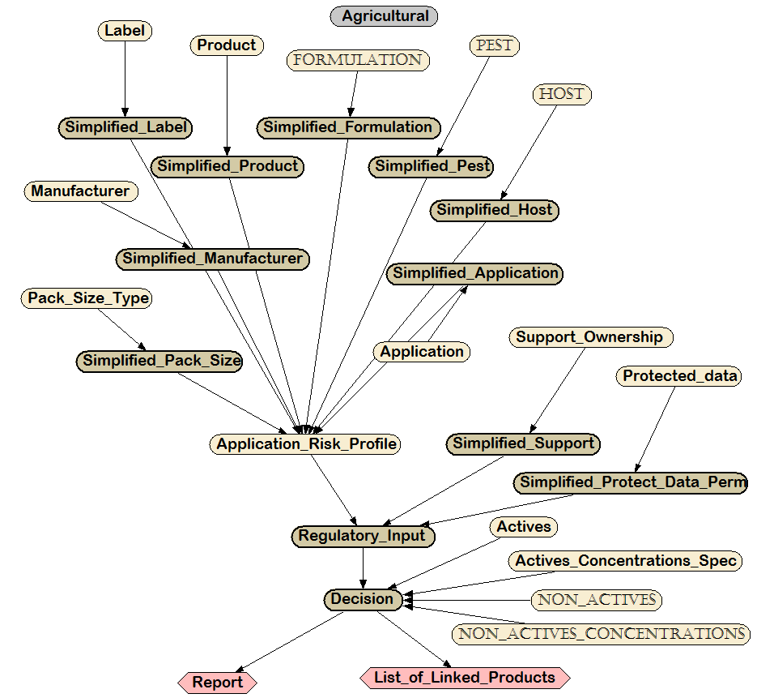
Figure 5. Full decision tree for agricultural chemicals. This representation omits the details of the states associated with the nodes.
When the decision tree is used for determining an application, the system will arrive at a decision based upon the applicant’s inputs and produce a report. This report will summarise the input parameters as entered by the applicant and include the reasons for each decision. This will provide transparent feedback for the user on the reasons for the outcome of the assessment. The system could be extended to provide additional information that may be used by an assessor to specify the detailed requirements of a desktop or full assessment.
The system could also link the product to other products that have been used as a reference for the assessment. The reason for the list of linked products is that if the status of a product is reassessed, then all other products that used it as a reference would have to be reassessed, to ensure their status is appropriate.

2.5 Feedback
Risk management systems based upon a ‘lighter touch’ are effective only if there is clear feedback between decisions and the outcomes of those decisions as well as regarding the reliability and external use of automated assessments.
Surveillance and auditing aim to detect, assess, understand and prevent adverse effects of marketed chemicals and medicines. Notification and reporting of suspected adverse reactions arising with the use of products is not only a legal requirement but an essential source of new information.
Any screening level risk assessment system should also provide efficient incentives for industry to be vigilant in testing and reviewing safety and in reporting adverse events. Incentives can be created through recognising the reliability of well-regulated industry participants or industry sectors through the application of a sliding scale of audit scheduling. It encourages applicants to comply because continued adherence results in fewer audits and reduced compliance costs.
Figure 6 shows the structure of feedback for the decision tree. The version of the decision tree built for the veterinary medicines is augmented with four more nodes. The audit node may be composed of passive surveillance monitoring or targeted audits of particular proponents.

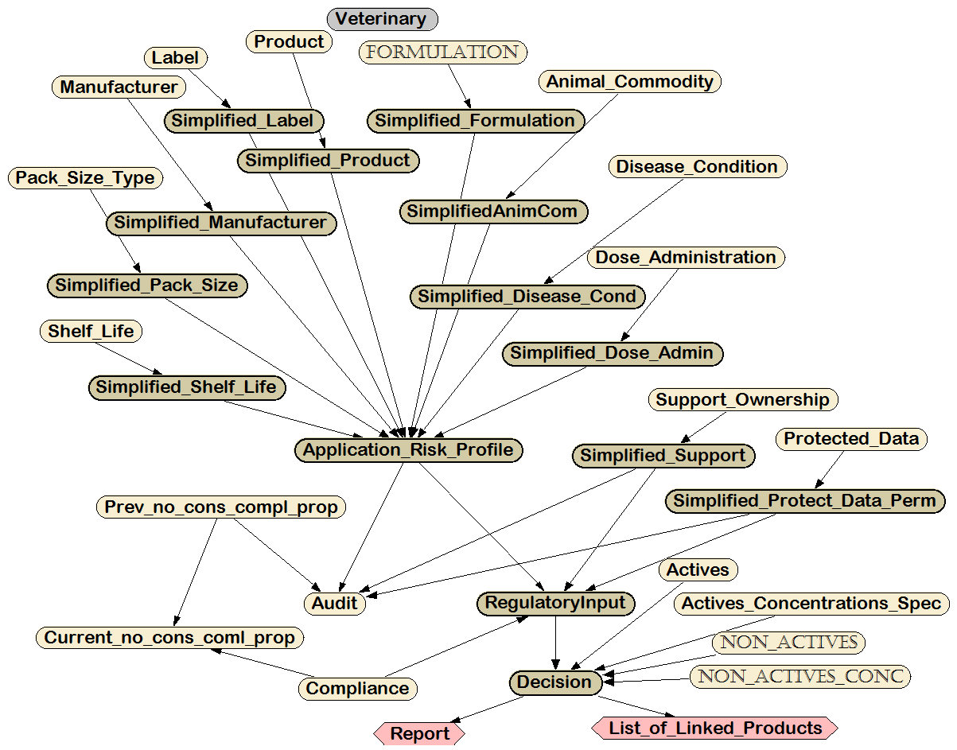
Figure 6. Decision tree for veterinary medicines, incorporating the audit feedback loop.

3. Discussion
A large proportion of current assessments conducted by the APVMA are essentially screening level assessments. If these can be readily identified, through the use of the tool, they can be managed through a process of self-assessment. If not suitable for self-assessment but not completely unknown, a desktop assessment approach could be developed further and utlised without the need for additional data. Products that do not satisfy these conditions would be subject to more complete assessments.

3.1 Turnaround times
As noted above, roughly 70% of the more than 3000 applications the APVMA receives each year are to ‘image’ an existing pesticide or veterinary medicine or to vary an existing product. Currently, most of these applications are approved within several days to a few weeks. If the automated system is implemented and the majority of the applications that image an existing product satisfy the conditions for self assessments, then the turn-around time would be reduced from several days to several hours.
There are some exceptions. Assessments that involve obtaining permission and support from owners of products or data would need to be confirmed independently by the APVMA before the submission could be approved. Thus, a request for assessment could be delayed while permissions and support are confirmed.
The system may reduce the turnaround times for desktop assessments by retaining information for assessors on the reasons why a self-assessment was not allowed. This information may assist them to identify critical information and to complete assessments relatively efficiently.

3.2 Data requirements and costs
The APVMA will need to balance the efficiency of self-assessments with revised processes for examining and tracking such products once in the market , and a more rigorous audit program that rewards regularly compliant individuals and companies. There will be on-going costs associated with a more vigorous, randomized auditing system. The targeted audits will need to satisfy the APVMA that the claims made in self-assessments are accurate, and that the applicant has retained all requisite data, permissions and other evidence of compliance.
For system users, data requirements will be no more than are required under the current system. In some instances, where comparisons with reference products can be substantiated, the data requirements may be reduced. The system will also clarify for users what data are and are not required.

3.3 Standard Development
The decision tree includes a state in the Formulation and Product node that provides a place for an application to comply with the requirements of an APVMA standard. The standard is a document detailing the circumstances under which the APVMA is satisfied for the particular group of products. If the application complies with these requirements there is no need for any further information to be provided. The process of developing these will be incremental, driven in part by industry interest and priorities in such an approach.

4. References
Arnot, J. A., MacKay, D., Webster, E., & Southwood, J. M. (2006). Screening level risk assessment model for chemical fate and effects in the environment. Environmental Science and Technology 40, pp 2316-2323.
Arnot, J. A., Brown, T. N., Wania, F., Breivik, K., & McLachlan, M. S. (2012). Prioritizing chemicals and data requirements for screening-level exposure and risk assessment. Environmental Health Perspectives 120, pp 1565-1570.
Bartholomaeus, A. (2015). Employment of Risk Proportionate Chemical Regulatory Regimes in Australia and Selected International Jurisdictions. Report to the APVMA. BartCrofts Scienceific Services for CEBRA. Unpublished Report.
Booze, T.F., Reinhardt, T.E., Quiring, S.J. and Ottmar, R.D. (2004). A screening level assessment of the health risks of chronic smoke exposure for wildland firefighters. Journal of Occupational and Environmental Hygiene 1, pp 296-305.
Borg, J.-J., Aislaitner, G., Pirozynskf, M. & Mifsud, S. (2011). Strengthening and rationalizing prharmacovigilance in the EU: Where is Europe heading to? A review of the new EU legislation on pharmacovigilance. Drug Safety 34, pp 187-197.
Burgman, M.A. (2005). Risks and decisions for conservation and environmental management. Cambridge University Press, Cambridge, UK.
Cramer GM, Ford RA & Hall RL (1978). Estimation of toxic hazard--a decision tree approach. Food and Cosmetics Toxicology 16, pp 255-276.
EFSA (2006) European Food Safety Authority. Guidance of the Scientific Committee on a request from EFSA related to Uncertainties in Dietary Exposure Assessment. Request No EFSA-Q-2004-019. The EFSA Journal 438, pp 24-54.
EPA (1993) US Environmental Protection Agency. A guidebook to comparing risks and setting environmental priorities. Office of Policy, Planning and Evaluation. EPA 230-B-93-003.
EPA (2001) US Environmental Protection Agency. The role of screening level risk asessments and refining contaminants of concern in baseline ecological risk assessments. Office of Solid Waste and Emergency Response. Publication 9345.0-14. EPA 540/F-01/014.
EPA (2004) US Environmental Protection Agency. Air toxics risk assessment reference library. Volume 1. Technical Resource Manual. Office of Air Quality Planning and Standards. EPA, Triangle Park, North Carolina. EPA 453-K-04-001A.
Fischhoff, B. & Morgan, G. (2008). The science and practice of risk ranking. Horizons 10, pp 41-47.
Florig, H.K., Morgan, M.G., Morgan, K.M., Jenni, K.E., Fischhoff, B., Fishbeck, P.S. & DeKay, M.L. 2(001). Risk Analysis 21, pp 913-921.
Hansson, S.O. & Ruden, C. (2006). Priority setting in the REACH system. Toxicologcal Sciences 90, pp 304-308.
Hobday, A. J., Smith, A. D. M., Stobutzki, I. C., Bulman, C., Daley, R., Dambacher, J. M. & Zhou, S. (2011). Ecological risk assessment for the effects of fishing. Fisheries Research 108, pp 372-384.
IPCS (2008) (International Programme on Chemical Safety) World Health Program Harmonisation Project Document Number 6. Part 1. Guidance Document on Characterizing and Communicating Uncertainty in Exposure Assessment. [online] http://www.who.int/ipcs/publications/methods/harmonization/exposure_assessment.pdf?ua=1
Kroes R., Renwick A.G, Cheeseman M Kleiner J., Mangelsdorf I., Piersma A., Schilter B., Schlatter J., van Schothorst F., Vos J.G., & Würtzen G. (2004). Structure-based thresholds of toxicological concern (TTC): guidance for application to substances present at low levels in the diet. Food Chem. Toxicol. 42, pp 65-83.
Lapenna, S. & Worth, A. (2011). Analysis of the Cramer classification scheme for oral systemic toxicity - implications for its implementation in Toxtree. JRC Scientific and Technical Report EUR 24898 EN – 2011. European Commission Joint Research Centre Institute for Health and Consumer Protection, Ispra, Italy.
Long, J., & B. Fischhoff, B. (2000) Setting risk priorities: A formal model. Risk Analysis 20, pp 339-351.
NRC (2011) (National Research Council). A risk-characterization framework for decision-making at the Food and Drug Administration. Committee on Ranking FDA Product Categories Based on Health Consequences, Phase II; National Academy of Sciences. The National Academies Press, Washington, D.C.
WHO (2002). The importance of pharmacovigilance: safety monitoring of medicinal products. World Health Organization, UK.
Wolt, J.D., Peterson, R. K. D., Bystrak, P. & Meade, T. (2003). A screening level approach for nontarget insect risk assessment: Transgenic Bt corn pollen and the Monarch Butterfly (Lepidoptera: Danaidae). Environmental Entomology 32, pp 237-246.

Appendix 1: Hypothetical Examples

Example 1 - New product
- containing low risk ingredients (reference to published list to be developed)
- approved actives, approved non- actives
- new label
- with no reference product
- all constituents appear on the label
- proposed use patterns – cats – no place for this in the tree (should it be?)
- Ideally online approval, but
- New product type & new label ≠online approval
- Maybe “label” could be checked for meeting the standards. If it does then online
Comments: online approval would be appropriate through selecting ‘meet the standard’ under the label tab (see above)

Example 2 - New product
- similar to existing product - different only in non-active constituents contained within the formulation
- approved actives, approved non- actives
- new label
- with no reference product
- reference product is owned by the applicant
- proposed use patterns – dogs, cats
- Non-actives are not visible in the application
- Where does a “reference product” place the “formulation”?
Comments: d) and e) are conflicting one or the other not both. Through the addition of ‘similar to approved’ within the formulation tab combined with selecting the ‘ownership’ tab (reference product is therefore owned by the applicant) it still would fall into a desktop assessment to consider if the formulations were in fact similar.
UNLESS the non-actives had been approved for that applicant at the same rates for another product? In which case ‘online’ would be appropriate if the label was selected as ‘same as approved’

Example 3 - New product
- for minor species
- approved actives, approved non- actives
- new label
- reference products: those containing that active
- used in major species but not available for small animals
- proposed use patterns - guinea pigs, birds and rabbits kept as pets
- Ideally online approval, but
- New host & new label & new product ≠online approval
- Maybe “label” could be checked for meeting the standards
- Maybe “new product” could be the registered but with a different use, etc.

Comments: Online approval would only be possible if the appropriate standard was in place and then ‘meet the standard’ for the label would be appropriate.
Without a standard in place it would end up in the desktop assessment unless the use already existed on a registered product.

Example 4 - Registered product
- Add a use already on the label of a registered similar products (same active & concentrations)
- approved actives, approved non- actives
- minor variations or differences in the formulation
- no protected data associated with the reference product
- new label
- similar product owned by a different registrant, permission given
- proposed use patterns – cow

Comments: label would be described as ‘new label same as approved’
If formulation variations were ‘allowable formulation variations’, the label instructions were ‘same as approved’ and ‘support was given’ it could be an online approval.

Example 5 - Registered product
  - addition of a new pack size outside of the current approved range (from 25L to 50L)
  - approved actives, approved non- actives
- Currently in “Label like variations – Other”

Comments: covered by the new ‘pack size’ tab and would end up as a desktop assessment.

Appendix 2: The APVMA Risk Management Decision-Support System Glossary
The following list describes the intended meanings of each of the categories associated with the input fields for the decision tree (DT). They are arranged within each ‘parent’ node on the tree.
The yellow highlighted states/situations are those that would suit online approval if no other changes are made.
The turquoise highlighted states/situations are those that would suit online approval if only one is chosen and the rest are highlighted yellow.
The italic font shows states that could be implemented and would make the system more efficient, but are not currently available.

Application Risk Profile Nodes
Label
This node should capture the likely change/form of a product label resulting from the application
- Not Applicable
  - Consideration of the label is not required for this application. This category includes applications for active constituents.
- No Change
  - The changes being made to the product within the application to not impact on the label.
- New label – new product meets APVMA Standard
  - Satisfies the requirements of an APVMA standard for low risk products – can only meet the standard if the label is consistent with the labelling requirements of the standard.
- Notifiable (Allowable) Variations
  - Those changes to a label defined by the APVMA as ‘notifiable variations”: e.g. change label name (marketing name), change label as a result of either varying the net contents statement or removal of a use, etc.
- New Label– Identical Product
  - Registration of a new label for a product that is identical to a product that is already approved apart from the product name, registrant/manufacturer details and APVMA identifier.
- New Label – Registered product
  - Approval of a new label for an existing registered product where use patterns or other information changes but is not covered by the notifiable variation category.
- New Label – New Product
  - A new label for a new product.
Currently, the decision tree combines
  - 1- 2 (None and Not Applicable)
  - 3-5 (Allowed Variations)
  - 6-7 (New Label)
Product

- Not Applicable
  - The application is for an active constituent only (a new active constituent or one that is already approved and for which the applicant is seeking a variation)
- Existing registered product
  - The application would only be for a variation in this circumstance.
- New product registration –meets APVMA standard or low risk group
  - The product or class of products meets the APVMA’s standard for low risk products. This would include identical ‘repack’ registrations.
- New
Currently, the decision tree combines
  - 1, 2, (None or existing product)
  - 3 (Meets standard)
  - 4 ( New Product)
Formulation
- Not Applicable
  - The application is for an existing product where there is no changes being made to the product formulation
  - The application is for an active constituent (a new active constituent or one that is already approved and for which the applicant is seeking a variation)
- New -Identical to Registered
  - Applications for registration of an identical product (repack) or
  - Application for registration of a product that is pharmaceutically equivalent to an existing registered product (only for veterinary products)
  - Variation to an existing product that does not affect the formulation
- New - Allowable Formulation Variation
  - Minor chemistry changes that do not affect the product specifications or the physico-chemical properties of the product as defined by the APVMA requirements for Allowable formulation variations. Could include constituent substitution.
- New - Meets Standard
- The products satisfies the requirements of an APVMA standard for low risk products
- New –low risk product
- Any chemical product containing only the substances listed in the APVMA’s list of low risk ingredients AND satisfying all conditions appropriate for low risk products:
  - All active constituents and concentrations are listed on the label.
  - The product label or any other representations about the product, including product advertising, do not mention specific diseases or conditions or make specific claims, unless the claim appears on an APVMA approved list of such claims (to be developed).
- New
  - Application for registration of a new product not covered by the categories above.: e.g. new formulation, changed impurity profile of any active ingredient, combination of new actives

Currently, the decision tree combines
  - 1-5 (Not Applicable or Allowed Variations)
  - 6 (New Formulation)

Pest (agricultural)
- Not Applicable
  - Application is not for a product or
  - No changes are being made to the pest information for the product
- Identical to registered
  - Pest(s) are identical to those of an already registered product cited as the reference product.
- New Pest(s) – within a Pest Group
  - Pest(s) within the same APVMA- Pest Group as those for the registered product and not at the top of the pest grouping hierarchy. (E.g. If the pest group indicates moth as the ‘worst case’ and the approved product only indicates wasp, the applicant would need to provide data to include moth on the label. If moth was already on the approved product then wasp could be added without data – hierarchy of worst case)
- New Pest(s)
  - Addition of a new pest not present on the label of an existing product for that active constituent
Currently, the decision tree combines
  - 1-3 (Not Applicable and Identical / Allowed Pest)
  - 4 (New Pest)

Host (agricultural)
The crop or situation in which the product is to be used.

- Not Applicable
  - Application is not for a product, or
  - No changes are being made to the host information for the product
- Identical Host(s)
- Hosts are identical to those of an already registered product cited as the reference product
- New Host(s) – Approved Group
- Host(s) within the same APVMA-approved host Group as those for the registered product and not at the top of the host grouping hierarchy. This concept is the same as the hierarchy of worst case defined for New Pests(s).
- New Host(s)
  - Addition of a new host/situation not present on the label of an existing product for that active constituent

Currently, the decision tree combines
  - 1-3 (Not Applicable and Identical / Allowed Host)
  - 4 (New Host)

Animal / Commodity (for veterinary medicines)
‘Animal’ refers to the species, subspecies, variant or race under consideration. Commodity refers to the intended end use of the animal. Examples of changes in commodity include changes from beef cattle to dairy, merinos to fat lambs, and egg laying poultry to poultry bred for meat. Also captures different life stages of the same animal, e.g. puppy to dog.
- Not Applicable
  - Application is not for a product or
  - No changes are being made to the animal/commodity information for the product
- Identical to Registered
  - The product is intended to treat the same animal, at the same life stage and the animal has the same end use as the animal for which the reference product is already registered.
- New Animal or Commodity
  - The product is intended to treat a new animal, or the same animal but for a different end use (different commodity), or the same animal but different life stage.
Currently, the decision tree combines
  - 1-2 (Not Applicable and Identical Animal/ Commodity)
  - 3 (New Animal / Commodity)

Disease/Condition (for veterinary medicines)
- Not Applicable
  - Application is not for a product or
  - No changes are being made to the disease/condition information for the product
- Identical to registered
  - The product is intended to treat the same disease/condition as an already registered product
- New
  - The product is intended to treat a new disease/condition.
Currently, the decision tree combines
  - 1-2 (Not Applicable and Identical Disease/Condition)
  - 3 (New disease/Condition)

Application method details - timing rate, frequency, equipment (for agricultural products)
Application information includes concentration, frequency of application, timing, rate, interval between applications, withholding period, season of application and method of application.
- Not Applicable
  - Application is not for a product or
  - No changes are being made to the application information for the product
- Identical to a Registered Product.
  - New product is identical in all respects,.
- New
  - Any of the following changes will place a product in this category: changed rates, concentrations or frequency of applications, changed season of application, , changed method of application.
Currently, the decision tree combines
  - 1-2 (Not Applicable and Identical)
  - 3 (New Application)

Dose and Administration (for veterinary medicines)
Dose and administration information includes dose, age of treated animals, frequency of application, duration of treatment, timing, treatment interval, season of application and method of application
- Not Applicable
  - Application is not for a product or
  - No changes are being made to the dose or administration information for the product
- Identical to the Registered Product
  - Applications are identical in all respects.
- New
  - Any of the following changes: dose or frequency of applications, changed season of application, interval between applications, changed method of application or administration route, changed booster regime.
Currently, the decision tree combines
  - 1-2 (Not Applicable and Identical)
  - 3 (New Dose / Administration)

Shelf life (for veterinary medicines)
- NA
- Identical to the Registered Product
- New & meets specifications
  - Longer than that of the registered product, but meets finished specifications
- New
  - Longer than that of the registered product, but DOES NOT meet finished specifications
Currently, the decision tree combines
  - 1-3 (Not Applicable and meets specs)
  - 4 (New)

Manufacturer Not Applicable
- Same
- Manufacturer and manufacturing site identical to the registered product.
- New – new site owned by the applicant
- New
Currently, the decision tree combines
  - 1-2 (Not Applicable and Same)
  - 3 (New Manufacturer different owner)
  - 4 (New Manufacturer different owner)

Manufacturer (veterinary medicines)
- Not Applicable
- Same
- Manufacturer identical to the manufacturer of the registered product.
- Exempt
- Product exempt from requirements from manufacturer licensing requirements
- New local
- New overseas - From 1 March 2016 this will be covered by new Prescribed Variation 2
Currently, the decision tree combines
  - 1-4 (Not Applicable and Allowed Variation)
  - 5 (New Overseas Manufacturer)

Pack Size and Type
- Not Applicable
  - Application is not for a product or
  - No changes are being made to the pack size information for the product
- Identical
  - Pack size and type the same as the registered product
- Within approved range
  - e.g. currently 5L and 25L pack sizes are recorded. A 10L pack would be within the approved range whereas a 40L pack would not. Notifiable item 3 only applies to ag products, hoping to expand it to vet products
- Changed Pack or New Pack Size/Type?
  - Pack size or pack type changes, affecting exposure
Currently, the decision tree combines
  - 1-3 (Not Applicable and Allowed Variations)
  - 4 (New)
Application Risk Profile Outcomes
- Known and low
  - All “not new”
  - New manufacturer same owner& the rest “not new”
  - New product & the rest “not new”
- Known and not low
  - New pack size & the rest “not new”
  - New label & the rest ”not new”
  - New shelf life & the rest “not new”(vet only)
  - New host or pest & the rest “not new”
  - New method of application & the rest “not new”
  - New formulation & the rest “not new”
  - New manufacturer & new method of application & the rest “not new”
  - New manufacturer & new product & the rest “not new”
  - New pack size & new product & the rest “not new”
  - New host or pest & new product & the rest “not new”
  - New host or pest & new pack size & the rest “not new”
- Unknown
  - All other combinations
Regulatory Input Nodes

Support and/or Ownership (for CIC information)
- Full ownership
  - The applicant owns the formulation (only for products)
- Partial ownership & Support
  - (for products) the applicant does not own the formulation, but has support from the parent company for the APVMA to reference the formulation information in support of registration of the new product, or
  - (for actives only) the applicant has support from the parent company for the APVMA to reference the active information in support of approval of an active constituent
- Partial ownership & No Support
  - (for products) the applicant does not own the formulation and has no support from the parent company to allow the APVMA to access the formulation information, or,
  - (for actives only) the applicant has no support from the parent company to allow the APVMA to access the active information.
Currently, the decision tree combines
  - 1-2 (Support)
  - 3 (No support)

Support - Protected data
- NA
  - no reference product
- No protected data
  - there is no protected data associated with the reference product
- Protected data & Permission
  - there is protected data associated with the reference product and permission is given to access the data
- Protected data & No permission
  - there is protected data associated with the reference product, but permissions to access is NOT given

Currently, the decision tree combines
  - 1-3 (NA or Permission given)
  - 4 (No Permission)
Regulatory Input Outcomes
- Low category A
  - Known and low risk profile & support & permission
- Low category B
  - Known and low risk profile & support & no permission
  - Known and low risk profile & no support & permission
  - Known and not low risk profile & support & permission
- Medium category C
  - Known and low risk profile & no support & no permission
  - Known and not low risk profile & no support & permission
  - Known and not low risk profile & support & no permission
  - Known and not low risk profile & no support & no permission
  - Unknown risk profile
Decision nodes
Active Ingredients
- Approved
- Active constituent approved by the APVMA
- S14A exempt
  - The active constituent is exempt from requiring approval by the APVMA
- New
Active Concentrations and Standard
- Within approved ranges
- Concentrations within existing approved ranges, or
- Concentration less than lower approved limit, or
- Impurities are validated in accordance with the APVMA guidelines.
- Outside approved ranges
  - Concentrations greater than existing approved range.
  - Impurities are not validated.
Non-Active Ingredients
- Existing
- New
Non- Active Concentrations
- Within approved limits
- Outside approved limits

Decision Outcomes
- Online approval
  - Regulatory input of low category A and all actives and non-actives approved and within limits
- Not online (desktop or full assessment)
  - All the rest

Report
- All choices made on the way are recorded in the report. In case online is not approved, the details will help decide if the application needs a desktop or a full assessment.
List of linked products
- If judgements about the safety of a product were to change, then all the assessments that used this product as a reference would have to be re-examined

Appendix 3: Additional figure
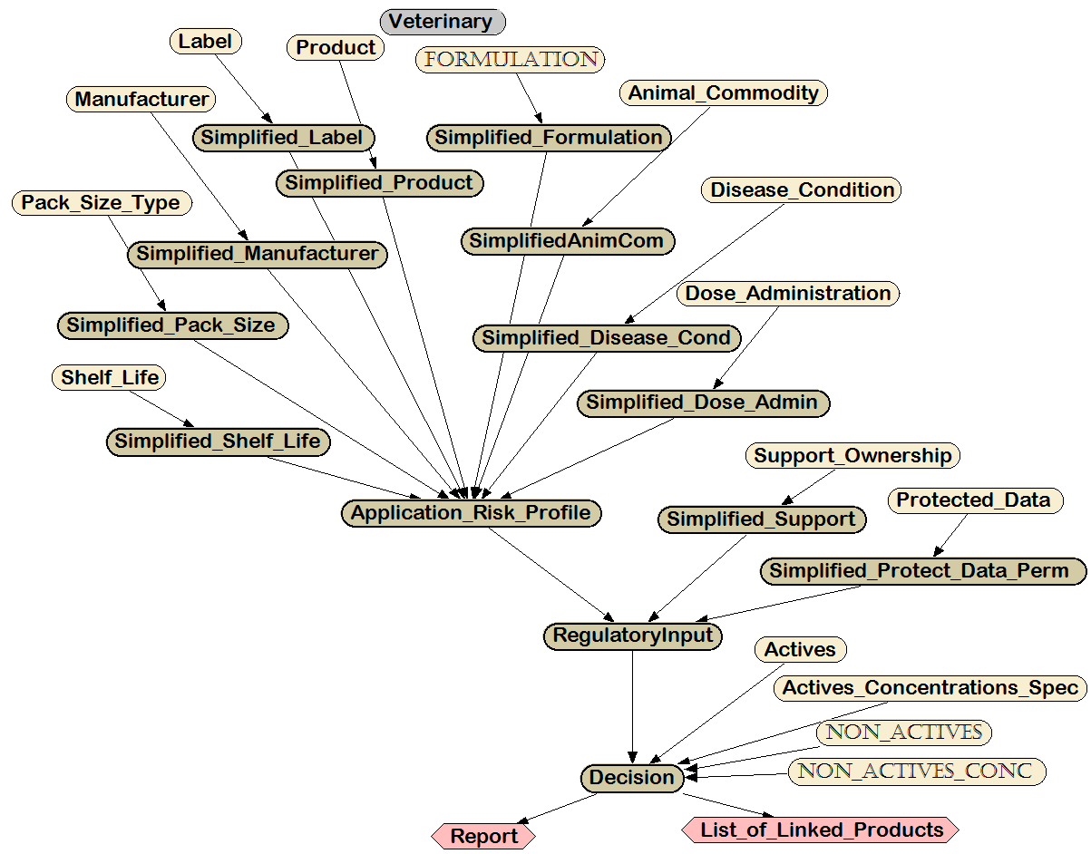

Figure 7. Full decision tree for veterinary medicines. As in Figure 5, this representation omits the details of the states associated with the nodes.

http://apvma.gov.au/node/15931
ibid.
ibid.
ibid.
http://apvma.gov.au/node/629
http://apvma.gov.au/node/630
http://apvma.gov.au/node/631
http://apvma.gov.au/node/632
http://apvma.gov.au/node/625
http://apvma.gov.au/node/989
EPA 2001
Burgman 2005
Hobday et al. 2011
EPA 1993, 2001
e.g., Hobday et al. 2011
e.g., Hobday et al. 2011
Long and Fischhoff 2000; Fischhoff and Morgan 2008. e.g. Florig et al. 2001
EPA 1993
Hobday et al. 2011, Booze et al. 2004, Wolt et al. 2003, EPA 2001, Arnot et al. 2006, 2012
Bartholomaeus (2015) provides complete details for this regulator and the systems for other regulators outlined in this section.
As above, full details appear in Bartholomaeus (2015)
USEPA, 2004
Kroes et al. 2004
Lapenna and Worth 2011
Hansson and Ruden 2006
e.g., EFSA, 2006; see also NRC 2011.
e.g., International Programme on Chemical Safety , IPCS 2008
Cramer et al. 1978
e.g. Kroes et al. 2004, Lapenna and Worth 2011
Kroes et al. 2004
WHO 2002, Borg et al. 2011
Borg et al. 2011
e.g., Hansson and Ruden 2006

