

Aquatic exposure estimates in Australian
pesticide environmental assessments
Runoff risk assessment methodology
April 2020
© Australian Pesticides and Veterinary Medicines Authority 2020
Ownership of intellectual property rights in this publication
Unless otherwise noted, copyright (and any other intellectual property rights, if any) in this publication is owned by the Australian Pesticides and Veterinary Medicines Authority (APVMA).
Creative Commons licence
With the exception of the Coat of Arms and other elements specifically identified, this publication is licensed under a Creative Commons Attribution 4.0 Australia Licence. This is a standard form agreement that allows you to copy, distribute, transmit and adapt this publication provided that you attribute the work.

A summary of the licence terms and full licence terms are available from Creative Commons.
The APVMA’s preference is that you attribute this publication (and any approved material sourced from it) using the following wording:
Source: Licensed from the Australian Pesticides and Veterinary Medicines Authority (APVMA) under a Creative Commons Attribution 4.0 Australia Licence.
In referencing this document the Australian Pesticides and Veterinary Medicines Authority should be cited as the author, publisher and copyright owner.
Cover image: iStockphoto (www.istockphoto.com)
iStockphoto images are not covered by this Creative Commons licence.
Use of the Coat of Arms
The terms under which the Coat of Arms can be used are set out on the Department of the Prime Minister and Cabinet website.
Disclaimer
The material in or linking from this report may contain the views or recommendations of third parties. Third party material does not necessarily reflect the views of the APVMA, or indicate a commitment to a particular course of action. There may be links in this document that will transfer you to external websites. The APVMA does not have responsibility for these websites, nor does linking to or from this document constitute any form of endorsement. The APVMA is not responsible for any errors, omissions or matters of interpretation in any third-party information contained within this document.
Comments and enquiries regarding copyright:
Assistant Director, Communications
Australian Pesticides and Veterinary Medicines Authority
GPO Box 3262
Sydney NSW 2001 Australia
Telephone: +61 2 6770 2300
Email: communications@apvma.gov.au.
This publication is available from the APVMA website.
Contents
Acknowledgements 1
Executive summary 2
1 Introduction 3
2 Screening level runoff risk assessment 5
3 Step 1: Refinement of runoff risk assessment 8
3.1 Hydrologic soil groups and cover complexes 8
Soil type 9
Soil cover 11
3.2 Slope of the land 15
4 Step 2: Refinement of runoff risk assessment 18
4.1 Water catchment size and land-use data 20
4.2 Data required 21
Streamflow 21
Rainfall values 22
4.3 Modelling pesticide runoff into streams 25
4.4 Confirmation of edge-of-field and instream modelling 26
4.5 Limitations of refined assessments 26
5 Summary 28
Appendix 1: Example for calculation of composite runoff curves 30
Summary of the procedure 37
Appendix 2: Worked example of screening level runoff risk assessment 38
Appendix 3: Worked example of Step 1 refinement of the runoff risk assessment 41
Appendix 4: Additional discussion of the Step 2 refinement of the runoff risk assessment (including instream analysis) 43
Appendix 5: Baseflow calculations 45
Abbreviations 47
Glossary 48
References 49

List of tables
Table 1: Soil composition according to hydrologic soil group 9
Table 2: Alignment of USDA Cover Type and HSG rainfall-runoff indexes with Australian agricultural practices 13
Table 3: Minimum rainfall values predicted for runoff commencement for different soil cover types 14
Table 4: Information for dryland cropping catchment basins in NSW, Vic., Qld and WA* 20
Table 5: Influence of rainfall on the predicted instream concentration* 24
Table 6: Curve numbers for USDA hydrologic soil groups for two different soil cover types and field situations 32
Table 7: Fraction of different hydrologic soil groups in dryland cropping regions of New South Wales and calculation of final composite runoff curve 33
Table 8: Runoff for mm rainfall (curve number 78) 35
Table 9: Calculation of runoff (Q) for different rainfall values based on the polynomial equation for the runoff curve shown in Figure 10 36
Table 10: Stepwise calculations for determining receiving-water concentration of pesticide and risk quotient 39
Table 11: Step 1 refinements of the runoff risk assessment—spatially different outcomes in Queensland and Victoria attributed to different soil types and slopes 42
Table 12: Dryland cropping for a fallow, bare soil scenario in Queensland¹ 43
Table 13: Summary of Baseflow Index (BFI) values for dryland cropping regions 46

List of Equations
Equation 1: Simplified formula for indirect loadings caused by runoff 5
Equation 2: Calculation for specific slope percentile 16
Equation 3: Calculation of 90th percentile slope 17
Equation 4: Pesticide concentrations in streams—instream equation (Probst, 2005) 25
Equation 5: Simplified formula for indirect loadings requires chemical specific information 31

List of figures
Figure 1: Graphic conceptualisation of the runoff risk assessment and real-world information used for refining the risk assessment 4
Figure 2 Graphic conceptualisation of the screening level risk assessment 5
Figure 3: Graphic conceptualisation of Step 1 refinement of the runoff risk assessment 8
Figure 4: Rainfall-runoff relationships for hydrological soil groups A, B, C and D and the composite rainfall-runoff relationship for New South Wales 10
Figure 5: Composite rainfall-runoff relationship by state for fallow, bare soil 11
Figure 6: Paddock with retained stubble from a cereal crop where no-till farming was practised 12
Figure 7: Queensland rainfall-runoff curves for bare soil and no-till scenarios 15
Figure 8: Slope analysis for sugarcane and horticultural areas in the Mackay/Whitsunday region 16
Figure 9: Graphic conceptualisation of Step 2 refinement of the runoff risk assessment 18
Figure 10: Whole rainfall distribution for the Oatlands, Tasmania district 23
Figure 11: Rainfall distribution after removal of rainfall values below that required to produce runoff from fallow, bare ground, Oatlands, Tasmania district 23
Figure 12: Rainfall distribution after removal of rainfall values below that required to produce runoff from background catchment, Oatlands, Tasmania district 24
Figure 13: New South Wales hydrologic soil group contributions 33
Figure 14: Runoff from given rainfall events, USDA, 2004. Curve number 78. 34
Figure 15: Runoff curve for NSW grains regions (curve number 78) 36
Figure 16: Composite runoff curve for fallow, bare soil in Queensland (curve number 93) 38
Figure 17: Composite runoff curve (curve number 87) for fallow, bare soil in Victoria 41
Figure 18: Distribution of theoretical instream concentrations 44

Acknowledgements
Australian state government data based on long-term monitoring information has been used to compile the data libraries relating to streamflow in the refined assessment approach described in this document. Without the availability of this quality information the approach would not be possible.
This paper focuses on cropping regions in Queensland, New South Wales, Victoria, South Australia and Western Australia where streamflow data has been assessed.
The following list acknowledges, with thanks, the state government agencies from which streamflow and river water-height data has been obtained:
Queensland
Water Monitoring Data Portal
watermonitoring.derm.qld.gov.au
© State of Queensland, Department of Natural Resources and Mines, 2015
New South Wales
Water NSW
realtimedata.waternsw.com.au/water.stm
© State of New South Wales, through Water NSW
Victoria
Department of Environment and Primary Industries
data.water.vic.gov.au
© State of Victoria, Department of Environment and Primary Industries, 2015
South Australia
WaterConnect, Government of South Australia
waterconnect.sa.gov.au
Government of South Australia, Department of the Environment, Water and Natural Resources, 2015 (Creative Commons Attribution 3.0 Australia licence)
Western Australia
Department of Water and Department of Regional Development (Water Information Reporting) wir.water.wa.gov.au
© State of Western Australia, Department of Water, 2015
The methodology developed and described in this document is the initiative of Chris Lee-Steere, Australian Environment Agency Pty Ltd.

Executive summary
This document outlines methodology for refining the aquatic exposure assessment component of environmental risk assessments of pesticides undertaken by the Australian Pesticides and Veterinary Medicines Authority (APVMA). The refinements described move away from a default-based, deterministic method involving conservative assumptions applied in any season and in any part of Australia to an evidence-based approach that uses local, real-world data describing slope, rainfall, streamflow, soil type and ground cover.
The screening level runoff risk assessment methodology remains unchanged. A simple Organisation for Economic Co-operation and Development (OECD)-developed equation accepted by the APVMA and used for many years in regulatory assessments is still applied. However, refinements of the screening level methodology increase realism within the aquatic exposure assessment. These refinements consider soil type and slope, and the influence of rainfall and streamflow on pesticide concentrations in runoff. By contrast, worst-case data is used for these parameters in a screening level assessment.
This report updates an earlier consultation document on runoff risk assessment methodology. A case in point is the incorporation of the relationship between the clay content of soil and rainfall runoff in an Australian context. The methodology utilised was developed by the United States Department of Agriculture (USDA). The risk assessment is amenable to refinement by the inclusion of data on land slopes, the modelling of water catchments, and the incorporation of differential effects of land use (the public is able to access this information from governmental datasets).
In the methodology described in this report, data libraries for streamflow in Australia are constructed using long-term data from over 570 stream-monitoring stations from New South Wales, Victoria, Queensland, and Western Australia. Cumulative frequency distributions for receiving-water concentrations resulting from runoff are developed which allow a quantitative assessment of risk.
Methodology producing detailed aquatic exposure assessments at the required spatial and temporal resolution is now possible utilising real-world streamflow, soil composition and rainfall data.

Introduction
The screening level rainfall-runoff methodology used by the APVMA when undertaking environmental risk assessments of agricultural chemicals and veterinary medicines is explained by the Standing Council on Environment and Water (SCEW, 2009). This deterministic approach to environmental assessment estimates the potential of an adverse event by deriving a risk quotient. It compares risk quotient values to levels of concern when drawing conclusions on risk.
Screening level methodology for estimating environmental concentrations of pesticides arising from runoff involves a ‘one size fits all’ approach that applies conservative default values. A risk deemed to be acceptable at this level does not require further assessment. However, with this approach, further refinement to take additional real-world information into account, thereby adding context around a risk quotient, is not possible.
In 2015 the APVMA published a new runoff assessment methodology to refine aquatic exposure estimates in Australian pesticide environmental risk assessments. That document provides the primary reference in support of this current document and should be read in conjunction with this document.
In the 2015 methodology, aquatic exposure is considered in steps of decreasing conservatism by increasing the usage of real-world data where available. The assessment determines if the risk posed by an active ingredient or product is acceptable. The refinements used in the exposure assessment can vary according to the product and usage, and may involve factors such as soil composition, the slope of the land, model-derived pesticide concentrations in streams, and ground cover. As more of these lines of evidence are included, assessments on spatial and temporal scales can be considered, recognising that risk is not uniform and depends on the characteristics of the receiving environment.
Figure 1: Graphic conceptualisation of the runoff risk assessment and real-world information used for refining the risk assessment
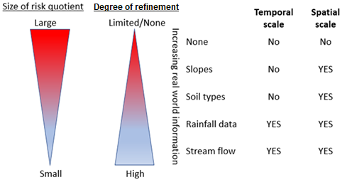
Following consultation on the APVMA 2015 methodology, a major change was incorporated into the approach. The change relates to the proposed runoff curves and concerns raised regarding their application not adequately predicting exposure for soils with clay contents higher than those for loams. Hence, the revised methodology described in this document applies the available knowledge on clay content in Australian agricultural soils and adopts a greater array of curve numbers which has become available from the USDA.
A second change to the 2015 proposal is the removal of ‘Step 2’ in the runoff risk assessment framework (described in APVMA, 2015 Refinement of aquatic exposure estimates in Australian pesticide environmental assessments [Figure 7, page 17]). This change reflects input from the Department of the Environment and Energy (DoEE) which noted that interpretation issues associated with Step 2 were too difficult to apply routinely, and that application of Step 2 should be considered separately on a case-by-case basis as required.
The initial risk assessment utilising the screening level methodology calculates risk using worst-case inputs and conservative assumptions. It is not designed to realistically model any particular situation, but rather to produce a conservative, worst-case estimate of risk. Such an assessment is useful for excluding low risk chemicals from further consideration.
Refinements to the risk assessment may incorporate additional real-world data while retaining conservative features such as the maximum pesticide runoff from a field. Consider, for example, the cropping areas of Queensland and Western Australia, which have different climates and soil types. The utilisation of real-world data facilitates improved modelling and allows for better accounting of the risks peculiar to the Queensland and Western Australia environments.
The refined aquatic-exposure methodology presented here can utilise distributions of theoretical receiving-water concentrations in cropping areas. It does this by considering the soil types and slopes in different agricultural regions and through incorporating long-term rainfall and streamflow data for the regions under consideration. The result is a quantified measure of exposure based on real-world data.

Screening level runoff risk assessment
The risks posed by the aquatic exposure to pesticide contained in runoff from rainfall are estimated from scientific assessments.
As mentioned previously, the screening level assessments conducted initially model a worst-case scenario for risk determination. The procedure allows for the assessment of the risks presented by all pesticides, and precludes those considered to be a low risk from additional assessment. However, the lack of information applied at this screening step results in ultra-conservative outcomes, which can incorrectly point to an unacceptable risk when none exists.
In order to overcome this situation, refined risk assessments utilising real-world data are indicated. The refinement process applicable to runoff risk assessments is depicted conceptually in Figure 2.
Figure 2 Graphic conceptualisation of the screening level risk assessment
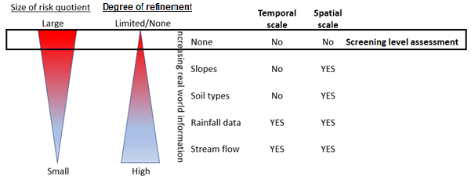
An OECD project on aquatic risk indicators developed, tested and evaluated several different indicators for agricultural pesticides; each of the indicators was considered useable by OECD member countries. The approach preferred and chosen applies a base model algorithm, and has been used environmental risk assessments in Australia for several years.
Computerised models for determining indirect pesticide loading of water bodies caused by runoff were reviewed by the Forum for the Coordination of Pesticide Fate Models and Their Use (FOCUS) in the EU. Based on those analyses, it was considered that existing models were too complex and a ‘simplified formula for indirect loadings (SFIL) caused by run-off’ was proposed (OECD, 2000).
Equation 1: Simplified formula for indirect loadings caused by runoff
$$L\%_{runoff}=\left(\frac{Q}{P}\right)X f X\exp\left(-\frac{3XLn2}{{DT}_{50 soil}}\right)X 100/(1+Kd)$$
Where:
L%_{runoff} = Percentage of the application dose dissolved and available in runoff waters
Q = Runoff volume (mm/day)
P = Daily precipitation (mm/day)
DT_{50soil} = Half-life of the active ingredient in soil (days)
Kd = Ratio of dissolved to sorbed concentration
f = f covers a range of factors described by f₁ to f₄ below
f₁ = Slope factor, where f₁ = 0.02153 X slope + 0.001423 X slope² (for slopes <20 per cent)
f₂ = Influence of plant interception, PI(%) where f₂ = 1 –(PI/100/2)
f₃ = Influence of a densely covered buffer zone where f₃ = 0.083^{WBZ}. The term WBZ in this expression is the width of the buffer zone in metres. If the buffer zone is not densely covered with plants, the width is set to ‘1’. Vegetative filter strips are not currently considered in Australian assessments, hence this factor remains at ‘1’.
f₄ = A heterogeneity factor of 0.5 is applied at the screening level and Step 1 refinement of the runoff risk assessment. These steps assume runoff to a standard water body and apply 90th percentile slopes. It is assumed also that half the treated area contributes to runoff. When applied at Step 2 refinement of the runoff risk assessment, which incorporates instream assessment, it is assumed all the treated area contributes to runoff and this factor is set to 1. Mean slopes are applied with Step 2 refinements of the runoff risk assessment.
Australian assessments assume that a runoff event occurs three days after application. Degradation during this time will result in removal of some chemical from the soil and requires a knowledge of the chemical’s half-life for use in Equation 1.
It is important to note that Equation 1 considers pesticides in the dissolved phase only. The calculation described above determines the percent of applied chemical that will be available in runoff waters. The concentration of pesticide in the receiving-water is then assumed to distribute into receiving water in order to calculate the water concentration. A worked example of the screening level runoff risk assessment is presented in Appendix 2.
Australian screening level assessments have historically used a ‘standard receiving-water body’, which is defined as a catchment area of 10 ha draining into a 1 ha water body of 15 cm depth. Prior to 2015, the risk assessment approach linked the standard water body to a 100 mm rainfall event with 20 per cent runoff (Q/P = 0.2), parameters considered at that time to represent a worst-case scenario for pesticide runoff.
In 2015, the risk assessment approach moved away from the default runoff/rainfall ratio of 0.2 and applied runoff curves as described by the OECD (2000) and addressed in detail in APVMA (2015) [Section 5, page 13]. Consultation of the APVMA 2015 document highlighted that the curves generated would not provide appropriate exposure estimation for runoff from soils that have clay contents greater than those of loams. The application of pesticides on these soil types will therefore under-predict the involved risks.
In order to address the issue raised in the preceding paragraph, the methodology published in APVMA (2015) was amended. The revised approach, described in this document, relates to the use of Australian-specific soil data and, in particular, the clay content of top soils. In addition, USDA runoff curves for these soil types are used.
The USDA developed, over a period of decades, rainfall-runoff datasets that consider ground cover, soil type, and other variables (USDA, 2004a,b). In addition, the USDA constructed an equation describing the relationship between rainfall and runoff that produces an index number (also known as a rainfall-runoff index or a curve number), which ranges from 0 to 100. Low curve numbers are assigned to surfaces with low runoff potential whereas high curve numbers are assigned to surfaces with high runoff potential. Section 3.1 of this report explains how Australian specific rainfall-runoff curves are derived and applied in an aquatic exposure assessment.

Step 1: Refinement of runoff risk assessment
When the screening level runoff risk assessment suggests a pesticide poses an unacceptable risk, real-world data can be incorporated in the risk assessment to better characterise aquatic exposure. In the first instance, this process involves the application of more appropriate rainfall-runoff curves based on knowledge of soil profiles and cropping scenarios. These characteristics, collectively, are referred to as hydrologic soil-cover complexes and are described in Section 3.1.
A separate refinement involves the use of land slope information for different regions and this aspect is discussed in Section 3.2.
Both of these refinements allow aquatic exposure to be calculated on a spatial scale. The refinements result in updated values for L% from Equation 1. It is still assumed that the runoff is from a 10 ha catchment and is destined to a 1 ha pond with an initial water depth of 15 cm. A worked example of a Step 1 refinement of the runoff risk assessment is presented in Appendix 3 of this document.
A Step 1 refinement of the runoff risk assessment will generally result in risk quotients being less than those derived from a screening level risk assessment (see Figure 3).
Figure 3: Graphic conceptualisation of Step 1 refinement of the runoff risk assessment
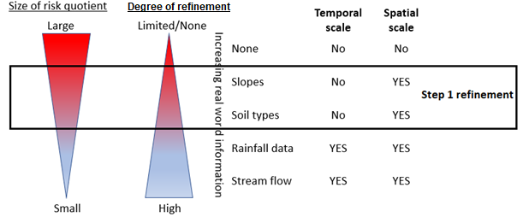

Hydrologic soil groups and cover complexes
The USDA has developed ‘hydrologic soil-cover complexes’ (USDA, 2004a) to facilitate the modelling of rainfall and runoff through the use of runoff curves. In this schema, soil type and land use are combined for modelling. A detailed description of how the runoff curves for different Australian regions are calculated, and how they apply in the runoff assessment, is presented in Appendix 1 of this document.

Soil type
Soil type is classified according to clay content into four hydrologic soil groups (HSGs) as follows: Type A has less than 10 per cent clay content; type B has 10–30 per cent clay content; type C has 30–40 per cent clay content; and type D has greater than 40 per cent clay content.
The USDA calculated rainfall-runoff indexes after examining rainfall data from various watersheds. A rainfall-runoff index value of 90 represents a smooth, impervious surface producing high levels of runoff and conversely, a value of 20 represents little runoff as occurs with deep gravel. Many of the refinements to the aquatic exposure risk assessment presented in this document utilise the USDA methodology, which has been modified by adopting Australian soil conditions.
The Australian Grains Research and Development Corporation and others have produced empirical data on the clay characteristics of the top 10 cm of Australian soils within cropping regions. Using these data, Australian soils have been classified according to clay composition into appropriate HSGs as shown in Table 1.
Table 1: Soil composition according to hydrologic soil group
State | No. of measurements | A | B | C | D
New South Wales | 575 | 13.74% | 67.66% | 8.70% | 9.91%
Victoria | 120 | 13.33% | 63.33% | 17.50% | 5.83%
Queensland | 97 | 2.06% | 7.22% | 10.31% | 80.41%
South Australia | 167 | 10.18% | 79.04% | 10.18% | 0.60%
Western Australia | 2004 | 74.25% | 24.25% | 0.85% | –
Tasmania | 219 | 0.91% | 18.26% | 36.07% | 44.75%
A <10 per cent clay, B 10–30 per cent clay, C 30–40 per cent clay and D >40 per cent clay.
Data sourced from soilquality.com.au.
The data in Table 1 illustrates two extremes of Australian soils viz. Queensland soils with a high clay content and Western Australian soils with a high sand (and low clay) content. By weighting the HSGs for the region under consideration, composite rainfall-runoff indexes can be generated for agricultural lands by state for various crops, cropping practices, and soil cover types.
Composite, regional rainfall-runoff curves are developed by using weighted average rainfall-runoff indexes according to the prevalence of HSGs within each region. The runoff from rainfall for different HSGs and soil cover types are assigned a curve number. Curves per se are generated by fitting rainfall-runoff data to polynomial equations. This process typically uses a software program such as Microsoft Excel (see Appendix 1, Figure 10 for an example). Rainfall-runoff curves and related issues are also discussed in detail in Appendix 1 of this document.
The example that follows demonstrates the approach for soils in New South Wales.
A composite rainfall-runoff curve that proportionately represents the HSGs present in New South Wales is shown in Figure 4. Also shown in Figure 4 are four USDA ‘default’ HSGs. The HSG rainfall-runoff indexes are A = 77, B = 86, C = 91 and D = 94, and weighting them with the soil composition data for New South Wales from Table 1 allows the composite rainfall-runoff index for NSW to be calculated:
$$0.1374 × 77 + 0.6766 × 86 + 0.0870 × 91 + 0.0991 × 94=86$$
The composite rainfall-runoff index for New South Wales is therefore 86.
Figure 4 also shows that runoff is greater and begins earlier for HSG D (with a clay content greater than 40 per cent) compared with soils that have a lower clay content (shown by the curves for HSG A, B and C).
Figure 4: Rainfall-runoff relationships for hydrological soil groups A, B, C and D and the composite rainfall-runoff relationship for New South Wales

The composite rainfall-runoff curves shown in Figure 5 demonstrate a similarity for New South Wales, Victoria and South Australia and highlight a significant difference for Queensland (high clay content and a composite rainfall-runoff index of 93) and Western Australia (high sand and low clay content and a composite rainfall-runoff index of 79).
Figure 5: Composite rainfall-runoff relationship by state for fallow, bare soil
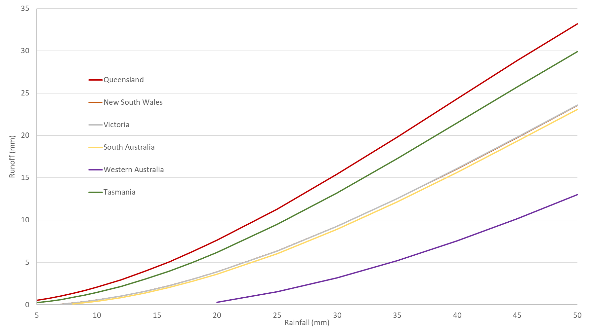
By utilising the approach described above, a composite rainfall-runoff curve can be generated for any region of Australia. This procedure allows for different regions—such as northern New South Wales and Queensland—to be considered separately.

Soil cover
Rainfall-runoff indexes are based on both soil composition and land use. The USDA has examined the effect of various land uses on the rainfall-runoff relationship and built a large catalogue of land cover types and associated rainfall-runoff indexes. Many of these scenarios are directly transferable to Australia, and others can be easily adapted.
USDA (2002) does not provide complete indicative rainfall-runoff indexes for all Australian cropping scenarios. For example, rainfall-runoff indexes are not available for no-till or other conservation tillage practices. Therefore, the risk assessment of runoff in Australian cropping scenarios such as these requires that listed classifications comparable to the Australian practice are used. The procedure is demonstrated by the following example.
Conservation tillage practices such as no-till farming are common in cropping regions of Australia (Thomas, 2007). No-till farming is the dominant farming system according to Grain Producers Australia, with around 85 per cent of grain farmers utilising it. A paddock during no-till farming is shown (Figure 6).
Figure 6: Paddock with retained stubble from a cereal crop where no-till farming was practised
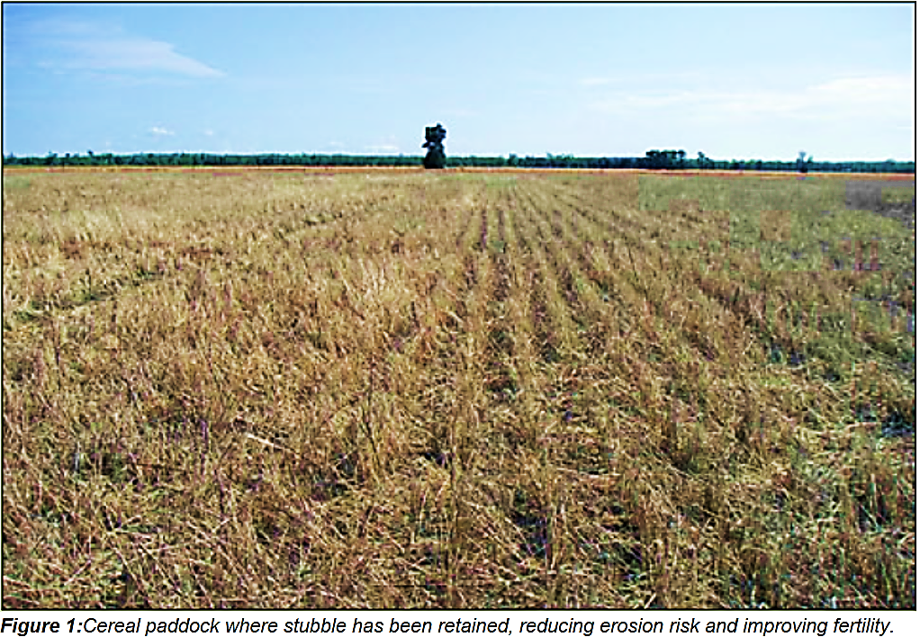
Image source: soilquality.org.au
From the perspective of an aquatic exposure risk assessment, cultivated land is most susceptible to runoff when it is bare of ground cover (or ‘fallow’)—a scenario used by farmers to conserve soil moisture (USDA, 2002). Because most Australian farmers use conservation tillage practices, a bare soil scenario is not an appropriate default model. Since bare soil scenarios represent a worst-case scenario, they continue to be used in screening level risk assessments.
No-till farming practices in Australia result in approximately 65 per cent ground cover (Freebairn, 2004). The USDA’s best match to this ground cover is the ‘poor hydrological condition’ classification. This scenario reflects a heavily grazed pasture with greater than 50 per cent mulch or plant cover and is reflective of that ordinarily found in Australian cropping where no-till or limited-till farming is practised. Similar methodology is used to match USDA ground cover types to other Australian scenarios when the need arises.
Table 2 shows the matching of a subset of USDA data to Australian scenarios, including land use. The matching of USDA cover types with Australian soil types and scenarios allows use of USDA rainfall-runoff methodology on a spatial scale (region specific) including rainfall-runoff indexes, and the ability to combine these scenarios with Australian land use and slope data described in the Multi-Criteria Analysis Shell (MCAS) database.
Table 2: Alignment of USDA Cover Type and HSG rainfall-runoff indexes with Australian agricultural practices
Australian scenario | USDA cover type | USDA HSG rainfall runoff indexes |  |  |  | Australian MCAS land use categories for slope determination
Australian scenario | USDA cover type | A | B | C | D
Turf, turf farms | Pasture, fair (50–75% ground cover) | 49 | 69 | 79 | 84 | Dryland horticulture | Irrigated horticulture
Turf, golf courses | Pasture, fair (50–75% ground cover) | 49 | 69 | 79 | 84 | Urban | Rural residential
Turf, Playing surfaces | Pasture, good (>75% ground cover) | 39 | 61 | 74 | 80 | Scenario specific. Set at 2%.
No till | Pasture, poor (<50% ground cover) | 68 | 79 | 86 | 89 | Dryland cropping
Row crop, straight row | Row crops, straight row | 72 | 81 | 88 | 91 | Dryland cropping
Row crop, contoured | Row crops, contoured | 70 | 79 | 84 | 88 | Dryland horticulture | Irrigated horticulture
Rights-of-way | Specifically derived scenario, non-regional.
Pasture | Pasture, poor (<50% ground cover) | 68 | 79 | 86 | 89 | Grazing modified pastures | Irrigated pastures
Orchards, pasture inter row | Orchard or tree farm; 50% wooded, 50% pasture | 57 | 73 | 82 | 86 | Dryland horticulture | Irrigated horticulture
Orchards, bare soil inter row | 50% wooded, 50% bare soil | 61 | 76 | 84 | 89 | Dryland horticulture | Irrigated horticulture
Legume | Close seeded or broadcast legumes | 66 | 77 | 85 | 89 | Dryland horticulture | Irrigated horticulture
Grain, straight row | Small grain, straight row | 65 | 76 | 84 | 88 | Dryland cropping
Fallow, crop residue | Fallow, crop residue | 76 | 85 | 90 | 93 | Grazing modified pastures | Irrigated pastures
Fallow, bare soil | Fallow, bare soil | 77 | 86 | 91 | 94 | Grazing modified pastures | Irrigated pastures
* USDA cover types and associated rainfall-runoff indexes are sourced from USDA 2004a.
** MCAS land use categories are obtained from the MCAS software detailed in section 3.2.
Table 3 shows the different amounts of rainfall required for runoff to commence with the different soil types and ground covers identified in Table 2. It is assumed that runoff commences when 0.1 mm runoff is predicted from the rainfall-runoff relationship.
Table 3: Minimum rainfall values predicted for runoff commencement for different soil cover types
Soil cover type | Qld | NSW | Tas. | SA
Fallow, bare soil | 2 mm | 6 mm | 3 mm | 7 mm
Row crop, straight row | 6 mm | 9 mm | 7 mm | 10 mm
Pasture | 9 mm | 11 mm | 9 mm | 12 mm
Figure 7 provides another example of land cover influencing predicted runoff. The rainfall-runoff curves shown are for bare soil (green) and no-till (red) scenarios in Queensland, and demonstrate how land cover influences the predicted runoff. The data used to develop the two runoff curves in Figure 7 is sourced from USDA (2004b) and Table 2.
In the bare soil scenario in Figure 7 (green curve), runoff is predicted to commence after approximately 5 mm of rainfall. At 10 mm of rainfall, approximately 1.5 mm (corresponding to 15 per cent of the rainfall) is predicted to run off and at 25 mm of rainfall, approximately 11 mm (corresponding to 44 per cent of the rainfall) is predicted to run off. A no-till scenario (Figure 7; red curve) increases the rainfall required for the commencement of runoff to 7 mm and results in less overall runoff compared to the bare-soil scenario. For example, it is predicted that 25 mm of rainfall results in approximately 6 mm of runoff, which corresponds to 24 per cent of the rainfall, in a stubble management scenario compared to 11 mm (corresponding to 44 per cent of the rainfall) for the bare soil scenario described above.
Figure 7: Queensland rainfall-runoff curves for bare soil and no-till scenarios

The overall level of ground cover may decrease prior to pesticide application in a no-till, stubble management scenario. This situation is best reflected by the USDA (2004b) ‘poor pasture’ rainfall-runoff index, which represents pasture with less than 50 per cent groundcover (see Table 2). In addition to examining the appropriate default ground-cover parameter for land under cropping, this example also serves to demonstrate the importance of modelling ground cover.

Slope of the land
The default slope for assessment of runoff as described in APVMA (2015) is 12.5 per cent. While this value can continue to be applied as a default, slopes within growing areas for different land uses are available and can be applied in assessments to further address spatial differences.
Slope values can be determined from a two-way analysis between slopes and land use using the Australian Government Department of Agriculture and Water Resources Multi-Criteria Analysis Shell (MCAS-S) tool, Version 3.1–2014. The MCAS data is based on the 2 km² resolution 2011 dataset. As an example of how to determine a slope value, 16 slope ranges can be modelled with the MCAS-S tool as follows: 0 per cent–0.25 per cent–0.5 per cent–0.75 per cent–1.0 per cent–1.25 per cent–1.5 per cent–1.75 per cent–2.0 per cent–2.5 per cent–3 per cent–4 per cent–6 per cent–8 per cent–10 per cent–20 per cent and >20 per cent. When slope values are used for calculation or reporting, the upper value of the range of slopes should be used since this maintains conservatism. For example, an area identified in the 3–4 per cent range for land slope is assumed to have a mean slope of 4 per cent.
The following example demonstrates use of the MCAS-S tool. Slopes up to 2 per cent in the Mackay/Whitsunday region in Queensland where sugarcane and horticultural crops are grown were analysed. Firstly, slopes up to 2 per cent are identified and sugarcane and horticultural areas delineated. Secondly, a ‘two-way analysis’ is performed to generate a map containing slope data. The output of the analysis is shown in Figure 8. Briefly, a key for slope percentages is shown in the left panel; the middle upper panel shows slopes in the total catchment; the middle lower panel shows areas where sugarcane and horticultural crops are grown; and the right panel combines the middle upper and lower panels in a two-way analysis.
Figure 8: Slope analysis for sugarcane and horticultural areas in the Mackay/Whitsunday region
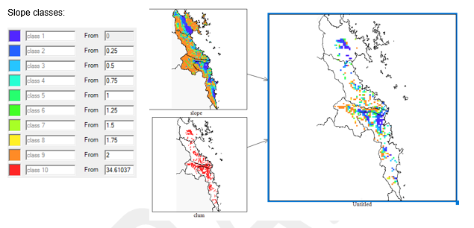
Data describing land slopes is not normally distributed, and an exponential distribution has been assumed. The exponential distribution is taken into account when calculating the slope of a region (expressed as a percent) using the following formula:
Equation 2: Calculation for specific slope percentile
$$-µ ×\log\left(\frac{\left(100-slope percentile\right)}{100}\right)$$
Where:
µ = mean slope (%)
Log = natural (base e) logarithm
An analysis of slopes for different land uses in Australia has identified that 12.5 per cent is probably overly protective and a value of 8 per cent is expected to cover >90 per cent of situations. It is recommended that a default value of 12.5 per cent is retained for horticultural uses in Tasmania.
If actual regional slope information is being applied, 90th percentile slope data should be used to represent a worst-case scenario during Step 1 refinement of a runoff risk assessment. After first using the MCAS tool to obtain mean slope data for the land area under consideration, the 90th percentile slope can be calculated using the following formula:
Equation 3: Calculation of 90th percentile slope
$$90th percentile=-µ ×\log\left(\frac{\left(100-90\right)}{100}\right)$$
Mean slope values more representative of real-world conditions can be applied during higher tier assessments.

Step 2: Refinement of runoff risk assessment
Step 2 refinement of the runoff risk assessment, which is conceptualised in Figure 9, incorporates instream analysis. The procedural methodology is described in APVMA (2015) [page 22] where it is referred to as ‘Step 3 Calculations’. In Step 2 refinement, real-world information relating to rainfall and stream-flow is incorporated into the risk assessment to improve exposure estimates. These data allow instream concentrations resulting from rainfall-induced runoff to be determined by stream-monitoring stations. The calculated instream concentrations are used to produce a cumulative distribution of theoretical instream concentrations. The distribution is theoretical because it assumes runoff from the crop being assessed has an equal probability of entering any of the streams or rivers within the region. Such assessments can be undertaken on spatial and temporal scales.
Figure 9: Graphic conceptualisation of Step 2 refinement of the runoff risk assessment
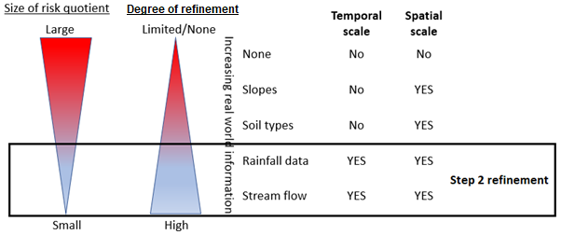
In addition to runoff waters entering the stream or river, flow rates can already exist from other sources such as stream baseflow and runoff waters originating from elsewhere in the catchment. The APVMA has published daily streamflow data for dryland cropping regions in Australia. These are the raw results and in order to properly determine the streamflow rate to apply in the exposure assessment, baseflow for each stream/river/creek must be calculated. Baseflow differs between regions and times of the year and is determined by methodology described in APVMA (2015) [page 23].
The methodology described for refined runoff assessments focuses on instream concentrations resulting from quick flow. Because quick flow is a direct result of rainfall, rainfall values are required for conducting instream analyses. A discussion of the use of rainfall values in the instream analysis is provided in APVMA (2015) [page 26]. However, that discussion is based on the runoff curves applied at the time, not with the updated approach described in this report. With the USDA soil-ground cover complex approach incorporating soil profiles for different regions, a background catchment rainfall value for each region needs to be determined to identify the appropriate rainfall at which runoff is expected to commence. This value is applied to the cumulative distributions of historic rainfall for different regions/states truncated above the background rainfall value to obtain 25th percentile and 75th percentile rainfall levels. When the latter are applied in an instream analysis, cumulative frequency distributions commence from the background rainfall value (see Section 4.2).
Rainfall statistics can be obtained from weather stations within cropping areas of interest, and the number of stations assessed should be proportionate to the size of the area being considered. It is for this reason that a much larger number of weather stations should be interrogated when assessing the Western Australian wheat belt compared to a single Queensland production horticulture region. It is suggested that where more than four stations are assessed within a region, the 90th percentile value is applied as this provides a conservative value of rainfall. For example, if 50 weather stations in a region have been assessed and the 25th percentile rainfall value is being obtained for the region, every weather station will have a different 25th percentile value. In such cases, the 90th percentile of the range of 25th percentile rainfall values should be adopted.
In order to perform a temporal assessment, rainfall data should be grouped by season for state-based assessments (viz. dryland, horticulture, pasture, turf) and by month for tropical/subtropical assessments. The monthly time-scale is considered important because summer-dominated rainfall patterns and wet-season time periods may not correspond with the standard seasons.
The establishment of appropriate streamflow and rainfall data facilitates the conduct of assessments on both a spatial and temporal scale. The underlying assumptions in calculating exposure is based on that implemented in the European FOCUS surface water stream scenario (FOCUS, 2001, 2011a) underpinned by the following considerations:
- Flows within any water body are dynamic, reflecting the various baseflow, runoff and drainage responses to rainfall events in the water body catchment. In the methodology described here, streamflow rates are historical and real-world and therefore already reflect these variables.
- Stream scenarios modelled in FOCUS are the most complex. It is assumed that pesticide will be applied on the same day to 20 per cent of the area of the upstream catchment. The stream thus receives pesticide solute in runoff waters from the entire upstream catchment. However, in order to adopt an extremely conservative approach to the exposure calculation, it is assumed that all pesticide solute derived from the treated area of the upstream catchment impacts upon the surface water body at exactly the same time.
- No pesticide solute is present in the baseflow fluxes that contribute water to the stream.
The instream assessment methodology does not put a restriction on catchment size. In this respect, real value stream monitoring data is used, which reflects the actual catchments. Two conservative FOCUS assumptions viz. (i) 20 per cent of a catchment is treated on the same day; and (ii) the entire treated area contributes to runoff, are adopted in the runoff methodology for the instream analysis. In addition, FOCUS applies the concept of ‘hydraulic residence time’. Residence time is not taken into account in this document. Rather, the concentrations described in the theoretical cumulative frequency distributions of instream concentrations are taken as peak modelled concentrations, which can also act as surrogates for lentic water bodies such as ponds and lakes. Further refinement in terms of use of time-weighted average concentrations and residence time can be applied on a case-by-case basis if required.
FOCUS uses a ‘mean annual minimum seven-day flow’ (MAM7) value when considering flow rates. The framework proposed here uses long-term flow rate data for the different regions.
Additional discussion of the Step 2 refinement of the runoff risk assessment incorporating instream analysis is presented in Appendix 4 of this document.

Water catchment size and land-use data
Data describing the real-world catchments under consideration can be applied to aquatic exposure risk assessments. At the highest tier of assessment, the standard assumptions that 20 per cent of a catchment is treated on the same day, and that solute from the catchment area impacts upon the surface water body coincidently with solute from the field, are retained. These assumptions are conservative and protective in their effects.
The example presented in Table 4 is based on dryland-cropping regions. Catchments as well as the size and cropping proportion for each catchment are listed. This data, which is derived using MCAS software, can be utilised to refine the runoff risk assessment.
Table 4: Information for dryland cropping catchment basins in NSW, Vic., Qld and WA*
Catchment | Size (ha) | Cropped
New South Wales
Gwydir | 26 580 | 28.5%
Murrumbidgee | 81 684 | 16.4%
Lachlan | 90 788 | 18.6%
Namoi | 41 988 | 18.2%
Macquarie-Bogan | 74 756 | 16.0%
Castlereagh | 17 452 | 26.0%
Victoria
Avoca | 14 228 | 45.3%
Broken river | 7 104 | 15.4%
Campaspe river | 4 048 | 11.3%
Goulburn river | 16 852 | 5.2%
Loddon river | 15 696 | 15.5%
Mallee | 41 520 | 29.5%
Murray-Riverina | 15 012 | 15.5%
Wimmera | 30 352 | 52.3%
Queensland
Balonne-Condamine | 162 636 | 7.3%
Border rivers | 48 008 | 19.4%
Burnett | 33 328 | 2.6%
Fitzroy | 142 672 | 5.6%
Moonie and Burdekin rivers | 14 392 | 17.0%
Western Australia
Esperance Coast basin | 20 080 | 67.2%
Albany Coast basin | 19 592 | 62.0%
Avon river | 117 660 | 62.9%
Moore-Hill rivers basin | 24 544 | 69.2%
Greenough/Murchison basin | 25 004 | 63.0%
* Data derived using MCAS software, as detailed in Section 2.1.

Data required
Instream analysis is a complex method of assessing exposure and requires a significant amount of data to perform. Data relating to soil characteristics and slopes in different use areas has been described above (Section 3). For instream analysis, this data as well as extensive information on streamflow rates and rainfall data are required.

Streamflow
The APVMA has published data libraries for streamflow rates for dryland cropping regions. The description of the approach adopted in the development and application of these data libraries is described in APVMA (2015) [Section 2, page 5 and Section 3, page 8].
Application of this methodology outside dryland regions will require further development of streamflow libraries. Examples are the production horticulture regions in Queensland and Northern NSW. The treatment of the data is described in APVMA (2015) [Section 3.1]. For each monitoring gauge station, streamflow will need to be grouped by season (for state-based assessments) or by month (for tropical/sub-tropical uses) thereby accounting for unique baseflow values of each station for each time period. Relevant 25th and 75th percentile streamflow rates should be determined.
An important component of the stream analysis is baseflow. If a baseflow component is not considered, streamflow rate percentiles will be based on the cumulative frequency distribution curves using the total dataset. This would likely result in overestimation of instream concentrations since the increased flow resulting from rainfall-induced runoff not being considered as an additional flow rate. In this situation, the rainfall value used for predicting runoff concentrations would remain unchanged, resulting in instream concentrations being overestimated. Baseflow calculations are described in APVMA (2015) [Section 6.3, page 23] and is addressed further in Appendix 5.

Rainfall values
To apply Step 2 refinement to the runoff risk assessment, users will also need to generate rainfall libraries for different use areas. It is recommended that sites have at least 10 years continuous rainfall data which should be grouped on a temporal scale as per streamflow data. Relevant 25th and 75th percentile rainfall values should be determined based on the rainfall distribution curves after accounting for base rainfall (this is the level of rainfall at which runoff in a region is assumed to commence).
The need to determine a baseflow rate when considering streamflows is discussed above. In a similar manner, the choice of an appropriate rainfall value for use in runoff modelling is required. In the methodology described in this document, the streamflows used are historical and are not adjusted for rainfall. Importantly, it is noted that higher rainfall will lead to higher instream concentrations. Section 3.1 demonstrated the impact of land cover on the amount of rainfall required to cause runoff.
Streamflows generally reflect their catchment characteristics to a greater extent than the cropping situation being assessed. Therefore, the establishment of a background catchment is recommended when determining final rainfall values for different states and regions. For example, the curve numbers for ‘Herbaceous—mixture of grass, weeds and low-growing brush, with brush the minor element’ from USDA (2004a) could be applied to a background catchment.
If it is assumed that not all areas of the catchment are fully covered, a ‘Fair’ hydrologic condition could be applied. This results in soil groups A,B,C and D having curve numbers of 0, 71, 81 and 89, respectively. These curve numbers are used to calculate a composite curve number for different states (see Table 1 for soil composition) and the rainfall required to generate ≥0.1 mm of runoff. The required rainfall is 9 mm in Tasmania and Queensland, 16 mm in South Australia and 22 mm in Western Australia.
The approach described above maintains the conservativeness of the model. As mentioned previously, streamflow rates are based on historical data and higher rainfalls result in higher instream concentrations. If the background catchment is not accounted for, the rainfall values entered into Equation 1 will be too low and instream concentrations will be underestimated. This is demonstrated in the following figures, which apply the positive long-term winter rainfall distribution data for the Oatlands district in Tasmania.
Figure 10: Whole rainfall distribution for the Oatlands, Tasmania district
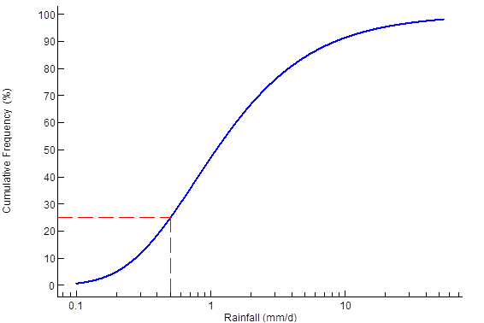
Figure 10 shows the whole rainfall distribution for the Oatlands district in Tasmania; the 25th percentile value equal to 0.5 mm of rainfall. This is consistent with low rainfall making a very high contribution to total rainfall. However, Table 3 shows that 3 mm of rain is required for runoff to commence. When taken together, these data indicate that runoff from fallow, bare soil will never occur. This is clearly invalid.
Figure 11: Rainfall distribution after removal of rainfall values below that required to produce runoff from fallow, bare ground, Oatlands, Tasmania district
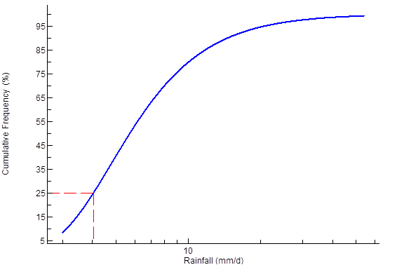
When rainfall values below that needed to produce runoff from fallow, bare soil situations, which in the case of a typical Tasmanian soil profile is 3 mm, are removed from the distribution, the 25th percentile rainfall value is 4 mm/day. However, this does not account for the higher rainfall needed in the wider catchment to produce runoff, and will still result in an under prediction of runoff to match the corresponding streamflow.
Figure 12: Rainfall distribution after removal of rainfall values below that required to produce runoff from background catchment, Oatlands, Tasmania district
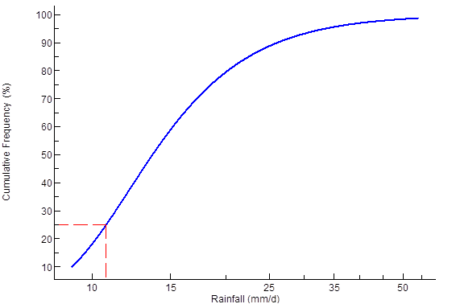
When rainfall values below that shown to produce runoff in the background catchment are removed from the data, a 25th percentile rainfall value of 11 mm is predicted. This allows for a more realistic assessment of runoff.
The influence of these different rainfall values on pesticide concentration in receiving water is demonstrated in the following example. Consider a hypothetical chemical with soil half-life of five days and Kd of 1 L/kg, and which is applied at a rate of 1000 g/ha. The influence of rainfall on the receiving-water concentration of the hypothetical chemical in a stream with a flow rate of 10 ML/d is shown in Table 5.
Table 5: Influence of rainfall on the predicted instream concentration*
Rainfall value | % chemical lost in runoff | Q/P | Instream concentration (µg/L)
4 mm (based on fallow, bare soil minimum rainfall) | 0.20 | 0.03 | 4.85
11 mm (based on background catchment minimum rainfall) | 1.16 | 0.16 | 27.9
* The streamflow remains constant at 10 ML/day for both scenarios.
The low rainfall scenario in Table 5 results in a prediction of runoff that is very low (Q/P is 0.03). The predicted instream concentration of 4.85 µg/L for the 4 mm rain event is significantly lower than the predicted instream concentration of 27.9 µg/L for the 11 mm rain event. Because streamflow characteristics reflect the wider catchment of the stream, it is necessary to include a catchment-based rainfall value rather than a crop cover-specific rainfall value. Failing to consider catchment-based rainfall can lead to aquatic exposure to pesticide being significantly underestimated.

Modelling pesticide runoff into streams
Equation 1 (described in Section 2) ‘drives’ the runoff assessment for determining the percent of chemical in dissolved-phase runoff. This is calculated based on a runoff curve and known chemical parameters relating to soil persistence and mobility. The result from Equation 1 allows an edge-of-field concentration to be calculated (see Appendix 2 for a worked example). At the screening step (described in Section 2 and Appendix 2) and the Step 1 refinement (described in Section 3 and Appendix 3), this edge-of-field runoff containing pesticide is distributed into a standard water body 1 ha in surface area and 15 cm deep. In Step 2 refinement of the runoff risk assessment which incorporates an instream analysis, the edge-of-field runoff is distributed into a flowing water body.
Berenzen et al (2005) expanded the formula to calculate potential pesticide concentrations occurring in a stream at a given time. These workers included in the formula, data on water discharge and durations of observed rain events when streamflows were increased.
The instream equation reported in Probst et al (2005) is applied as an extension to the screening level model:
Equation 4: Pesticide concentrations in streams—instream equation (Probst, 2005)
$$Pc = L_{\%runoff} × Pa × \left(\frac{1}{Qstream × ∆T}\right)$$
Where:
Pc = Simulated mean pesticide instream concentration (µg/L)
L_{%runoff} = Percentage of application dose dissolved and available in runoff water
Pa = Chemical applied to the simulation area (µg)
Qstream = Peak streamflow during heavy rain events (L/s)
∆T = Duration of heavy rain event (seconds)
The duration of the rain event (∆T) is an important consideration when using this extension. When mixing pesticide runoff with streamflow to predict instream pesticide concentrations, 24 hours rainfall is assumed to occur within one hour (that is, ∆T = 3600 seconds) for 25th percentile flow rates, and within two hours for 75th percentile flow rates.
The US Geological Survey categorises river flows greater than 75 per cent of maximum flow as above normal, 75 per cent to 25 per cent as normal, and less than 25 per cent as below normal. Below normal flow conditions are not considered here (with the exception of determining a representative baseflow index for each station) as it is assumed that streamflow following rainfall events leading to runoff will at least lead to normal, or above normal, streamflows.
The model requires a rainfall value to predict the edge-of-field concentration that is matched to the streamflow rate being assessed. For example, if 25th percentile streamflow is modelled, the 25th percentile rainfall value on the rainfall cumulative frequency distribution is applied (provided the background rainfall amount is exceeded). The corresponding 25th percentile flow rate above baseflow for the appropriate station is used as the Qstream input parameter. In this respect, Queensland contains 136 streamflow monitoring stations, which would produce 136 data points in a cumulative frequency distribution.
While the calculation of initial runoff to the standard water body assumes a catchment of 10 ha size with 50 per cent of the catchment contributing to rainfall-induced runoff, the instream analysis assumes 100 per cent of the treated area contributes to rainfall-induced runoff. It is additionally assumed that direct runoff of pesticide solute to the receiving stream is derived from 20 per cent of the catchment area. A mean slope value is applied in the calculations. The concentrations modelled in the theoretical cumulative frequency distributions of instream concentrations within the data libraries are peak concentrations, which can be applied to lentic water bodies.
To draw a conclusion on the potential risk, a predicted aquatic environmental concentration of pesticide is required. This is derived by plotting a theoretical distribution of the instream pesticide concentration using flow rate distributions.
Factors such as the region, season, scenario being modelled and streamflow percentile are used to construct cumulative frequency distributions for theoretical instream pesticide concentrations. Instream concentrations of pesticide are then modelled using flow-rates as input. This approach is applied quantitatively to deal with probabilities; it allows for more flexibility in the assessment of spatial and temporal differences, both within and between regions.
Time-weighted average concentrations and residence times may be employed to refine these data further. This step is undertaken on a case-by-case basis.

Confirmation of edge-of-field and instream modelling
Berenzen et al (2005) examined the predictions of the SFIL in 18 streams using runoff-triggered sampling. Pesticide concentrations associated with single-entry events caused by runoff were estimated accurately in the models used. The values used for predicting pesticide concentrations from discharge during surface water runoff varied from 10 L/s to 80 L/s. These values were up to 10 times higher than baseflow.
Significant correlation between the predicted and measured instream concentrations of pesticide was demonstrated. This finding provides reassurance that SFIL is a useful tool for modelling aquatic exposure.

Limitations of refined assessments
Refinements to the aquatic exposure model improve the flexibility and robustness of the risk assessment methodology. However, users should be aware of the following limitations:
- The runoff equation applied for estimating edge-of-field and receiving-water body concentrations only considers runoff, not other water or pesticide routes such as leaching or drainage.
- Runoff is only considered for the pesticide in the dissolved phase, not in the bound phase (as sediment). A separate assessment of sediment exposure may be necessary.
- Risk assessments involving significant degrees of refinement are more labour-intensive during both the assessment and enforcement phases.
- The availability and quality of data vary. For example, South Australia has little streamflow, which leads to a paucity of streamflow data while in Western Australia, monitoring began later at some remote sites than at other sites.
- Boosting the components in a model, and/or increasing the spatial resolution under consideration can rapidly increase the complexity and labour required to complete an aquatic exposure assessment. In the context of an environmental risk assessment, aquatic runoff modelling is only a single component of a larger assessment.

Summary
The deterministic screening level approach to environmental runoff risk assessments in Australia produces outcomes that are generally applicable to any season and any region of Australia. While existing risk assessment methods provide worst-case estimates, real-world data has not been used to model regional slopes, soils and seasonal streamflows or to consider regional rainfall characteristics. Therefore, the risk outcomes are without context and based on a ‘one size fits all’ approach.
The use of distributions for rainfall and rates of streamflow facilitates significant refinement of modelling methodology for aquatic pesticide exposure. Modelling to include environmental variability of spatial and temporal factors is now possible. The collation and selection of data libraries on streamflow and regional soil types in cropping regions in Australia are fundamental to the methodology described in this report.
The refined methodology described here applies to both new and existing agricultural pesticides. It allows exposure to pesticides resulting from runoff into aquatic environments to be modelled and estimated. The methodology is a valuable tool for regulatory decision-making in Australian environmental risk assessments.

Appendix

Appendix 1: Example for calculation of composite runoff curves
This Appendix provides a more detailed description of information presented in Section 3.1 and describes how the derived runoff curves inform Equation 1 (described in Section 2 and repeated below) for predicting the percentage of a pesticide lost in runoff and deriving exposure concentrations in surface water.
Computerised models for determining indirect loading to water bodies were reviewed in the EU by the Forum for the Coordination of Pesticide Fate Models and Their Use (FOCUS). Based on that review, it was considered that existing models were too complex and a simplified formula for indirect loadings (SFIL) caused by run-off was proposed (OECD, 2000).
Equation 1: Simplified formula for indirect loadings caused by runoff
$$L\%_{runoff}=\left(\frac{Q}{P}\right)X f X\exp\left(-\frac{3XLn2}{{DT}_{50 soil}}\right)X 100/(1+Kd)$$
Where:
L%_{runoff} = Percentage of the application dose dissolved and available in runoff waters
Q = Runoff volume (mm/day)
P = Daily precipitation (mm/day)
DT_{50soil} = Half-life of the active ingredient in soil (days)
Kd = Ratio of dissolved to sorbed concentration
f = f covers a range of factors described by f₁ to f₄ below
f₁ = Slope factor, where f₁ = 0.02153 X slope + 0.001423 X slope² (for slopes <20 per cent)
f₂ = Influence of plant interception, PI(%) where f₂ = 1 –(PI/100/2)
f₃ = Influence of a densely covered buffer zone where f₃ = 0.083^{WBZ}. The term WBZ in this expression is the width of the buffer zone in metres. If the buffer zone is not densely covered with plants, the width is set to ‘1’. Vegetative filter strips are not currently considered in Australian assessments, hence this factor remains at ‘1’.
f₄ = A heterogeneity factor of 0.5 is applied at the screening level and Step 1 refinement of the runoff risk assessment. These steps assume runoff to a standard water body and apply 90th percentile slopes. It is assumed also that half the treated area contributes to runoff. When applied at Step 2 refinement of the runoff risk assessment, which incorporates instream assessment, it is assumed all the treated area contributes to runoff and this factor is set to 1. Mean slopes are applied with Step 2 refinements of the runoff risk assessment.
The simplified formula has been applied in Australian runoff assessments for many years and is retained in the current methodology for calculating edge-of-field concentrations. The edge-of-field residue is derived from the treated field and its concentration is quantitated prior to it being distributed into either the standard water body (1 ha surface area and initial depth of 15 cm) or a flowing stream (a situation that applies to higher tier assessments only).
In calculating the percentage runoff, the SFIL requires both chemical specific information and input based on environmental factors (eg slope which is a component of ‘f’) and the relationship between the magnitude of a rainfall event and the amount of runoff that results.
Equation 5: Simplified formula for indirect loadings requires chemical specific information
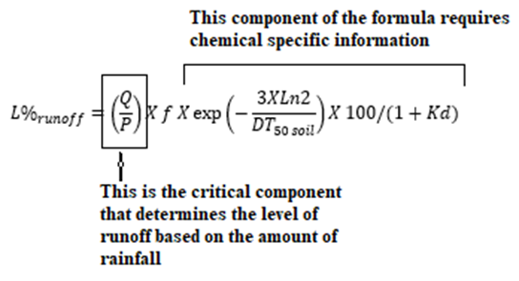
The runoff/rainfall relationship is determined by Q/P, which in turn is calculated from the dataset used in developing a runoff curve. In the initial consultation document (APVMA, 2015, Section 5, page 13), several runoff curves covering four scenarios (viz. bare moist soil, bare dry soil, covered moist soil and covered dry soil) were described. Each of the four scenarios had separate runoff curves for ‘sandy’ and ‘loamy’ soils.
During the consultation period concerns were raised that this approach, while an improvement on the previous method in which ‘Q/P’ was fixed at 0.2 (ie a 100 mm rain event resulting in 20 mm runoff) was considered likely to underestimate runoff, particularly for soils with a clay content greater than that of loams. It was suggested, therefore, that consideration be given to using USDA runoff curves, including many for clay-dominated soils.
In order to apply this approach, knowledge of soil clay levels is required. The required knowledge emerged when quality, relevant information was published around the time of the APVMA (2015) consultation. In the amended methodology reported here, USDA runoff curves using clay contents of Australian agricultural soils are generated. This approach allows a much wider application of runoff curves to reflect soil types in different regions as well as a wide range of ground cover types. However, it necessitates the development of a greater number of runoff curves compared to the number required by the approach described in APVMA (2015).
The aim of this Appendix is to demonstrate how runoff curves are developed. Straight row, grain crops in New South Wales have been selected for the purpose of demonstration.
In this approach, the combination of a hydrologic soil group (soil) and a land use and treatment class (cover) is referred to as a hydrologic soil-cover complex. Tables and graphs of runoff curve numbers (CNs) assigned to such complexes are published in the USDA’s National Engineering Handbook Part 630, chapters of which are available electronically. The four hydrologic soil groups (HSGs) based on clay content are A (<10 per cent clay), B (10–30 per cent clay), C (30–40 per cent clay) and D (>40 per cent clay).
The USDA assignment of curve numbers to hydrologic soil-cover complexes was a comprehensive process. Three salient points relating to the process are presented here. The reader seeking additional information on the process is referred to Chapter 9 of the Handbook.
The three salient points are:
- Literature searches for watersheds in single hydrologic soil-cover complexes identified watersheds for most of the listed complexes;
- An average CN for each watershed was obtained using rainfall-runoff data for storms of ≤ one day duration that resulted in annual floods. Watersheds were generally less than 1 square mile in size and their number per hydrologic soil-cover complex was variable.
- The CNs of watersheds in the same complex were averaged and all CNs for a cover were plotted. A curve for each cover was drawn with greater weight given to CNs based on data from more than one watershed, and each curve was extended as far as necessary to provide CNs for ungauged complexes.
In the event that additional data becomes available the CN approach can be updated, but at this stage it is assumed runoff behaviour in the US is similar to that in Australia for soils of the same hydrologic group and ground cover attributes. Hence these curve numbers are applied using knowledge of Australian soil characteristics in the different regions.
Chapter 10 of the USDA Handbook provides runoff for inches of rainfall for most of the curve numbers from 50 to 98. The rainfall metric is converted to mm for use in the Australian methodology.
Chapter 9 of the Handbook provides information on Hydrologic Soil-Cover complexes. It provides runoff curve numbers for agricultural lands (Table 9–1 in the Handbook) which have been used as the basis for determining final runoff curve numbers for the different regions/states in Australia. Two examples for dryland cropping are provided below:
Table 6: Curve numbers for USDA hydrologic soil groups for two different soil cover types and field situations
Cover description/treatment | USDA cover type | Curve number for USDA soil hydrologic group
Cover description/treatment | USDA cover type | A | B | C | D
Fallow, bare soil | Fallow, bare soil | 77 | 86 | 91 | 94
Grain, straight row | Small grain, straight row (poor hydrologic condition)¹ | 65 | 76 | 84 | 88
¹ Runoff is higher from soils of poor hydrologic condition compared to soils of good hydrologic condition. Soils of poor hydrologic condition are used as a default to maximise conservatism.
The example shown in Table 6 is based on a scenario involving ‘Grain, straight row’ and a soil of poor hydrologic condition.
Information for clay content in the grain production areas of NSW presented in Table 6 was sourced from soilquality.org.au.
Figure 13: New South Wales hydrologic soil group contributions
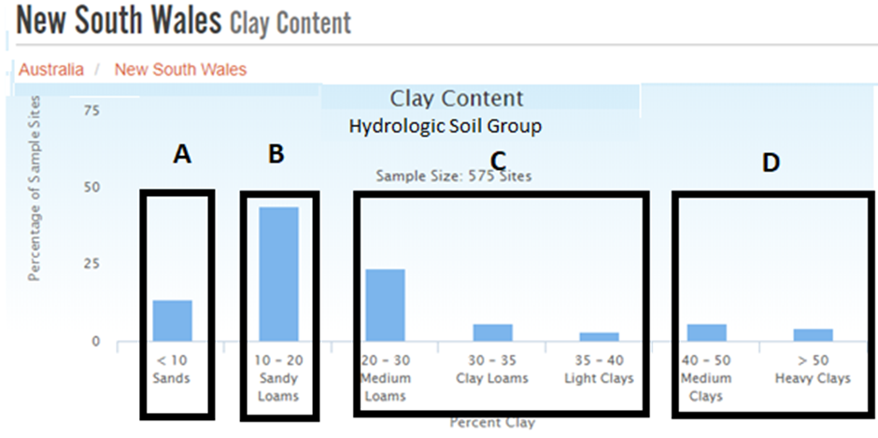
A single runoff curve for New South Wales for straight row, grain crops can be calculated based on the contribution of each hydrologic soil group to the overall NSW soil profile. This is shown in the table below:
Table 7: Fraction of different hydrologic soil groups in dryland cropping regions of New South Wales and calculation of final composite runoff curve
State/runoff curve | <10% clay (A) | 10–20% clay (B) | 20–40% clay (C) | >40% clay (D)
New South Wales | 13.74 | 43.83 | 32.53 | 9.91
Runoff curve | 65 | 75 | 84 | 88
Contribution to composite curve¹ | (0.1374 X 65)  8.93 | (0.4383 X 75)  32.87 | (0.3253 X 84)  27.33 | (0.0991 X 88)  8.72
Final composite curve number | =SUM of contributions from A, B, C and D = 77.8  The final composite curve is based therefore on curve number 78
¹ Calculated as runoff curve number X percent hydrologic soil group
The rainfall-runoff table from USDA (2004), Chapter 10 for curve no. 78 is shown below.
Figure 14: Runoff from given rainfall events, USDA, 2004. Curve number 78.
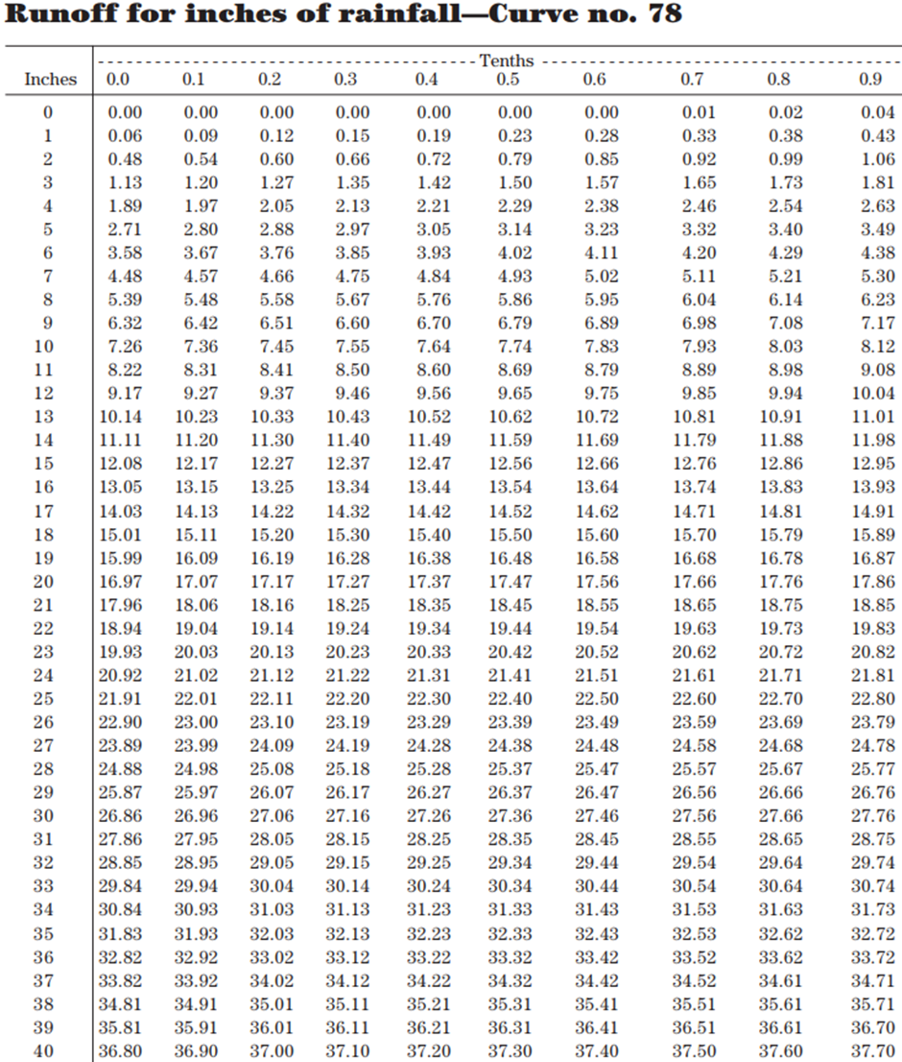
In the table above, the rainfall-runoff metric is inches. Since the Australian methodology described in this report requires rainfall to be measured in mm, the tabulated data is converted to mm by multiplying values measured in inches by 25.4.
Rainfall expressed as inches is shown in column 1, and expressed as tenths of inches is shown in row 1. Runoff values expressed as inches are shown in columns 2–11 (with the exception of row 1).
Table 8 presents rainfall-runoff data in mm for rainfall values ranging from 0 mm to 127 mm. The data is extracted from the USDA table (curve number 78) in which the rainfall-runoff metric is inches.
Table 8: Runoff for mm rainfall (curve number 78)
Mm | 0 | 2.54 | 5.08 | 7.62 | 10.16 | 12.7 | 15.24 | 17.78 | 20.32 | 22.86
0 | 0.0 | 0.0 | 0.0 | 0.0 | 0.0 | 0.0 | 0.0 | 0.3 | 0.5 | 1.0
25.4 | 1.5 | 2.3 | 3.0 | 3.8 | 4.8 | 5.8 | 7.1 | 8.4 | 9.7 | 10.9
50.8 | 12.2 | 13.7 | 15.2 | 16.8 | 18.3 | 20.1 | 21.6 | 23.4 | 25.1 | 26.9
76.2 | 28.7 | 30.5 | 32.3 | 34.3 | 36.1 | 38.1 | 39.9 | 41.9 | 43.9 | 46.0
101.6 | 48.0 | 50.0 | 52.1 | 54.1 | 56.1 | 58.2 | 60.5 | 62.5 | 64.5 | 66.8
127 | 68.8 | 71.1 | 73.2 | 75.4 | 77.5 | 79.8 | 82.0 | 84.3 | 86.4 | 88.6
The data in Table 8 indicates that runoff will not commence until rainfall exceeds 15.2 mm. Therefore, for the purpose of developing a rainfall-runoff dataset, the rainfall lower limit is set at 15.2 mm. The rainfall upper limit is defined such that 75th percentile rainfall value is captured. This requires knowledge of regional rainfall and in the example described, the rainfall upper limit approximates 55.88 mm (which corresponds to 50.8 mm + 5.08 mm in Table 8). A rainfall-runoff dataset is then developed with a rainfall lower limit of 15.24mm and a rainfall upper limit of 55.88 mm, using the rainfall and runoff values in Table 8. Finally a polynomial equation is generated for the dataset in Microsoft Excel.
The percentage of pesticide lost in runoff and available to pose an aquatic exposure risk is predicted from Equation 1. Values of ‘P’ and ‘Q’ for substituting in Equation 1 are derived from Table 8 (the term ‘P’ is a rainfall value; the ‘Q’ term is the runoff value that corresponds to a particular rainfall value defined by ‘P’). To demonstrate, a rainfall event of 50.8 mm (P value) is associated with 12.2 mm of runoff (Q value), giving a Q/P value of 0.24. From an aquatic exposure perspective, the worst case scenario occurs when the value of Q/P is maximal. This value of Q/P is substituted in Equation 1 for predicting the percentage of pesticide lost in runoff and available to pose an aquatic exposure risk.
Figure 15: Runoff curve for NSW grains regions (curve number 78)
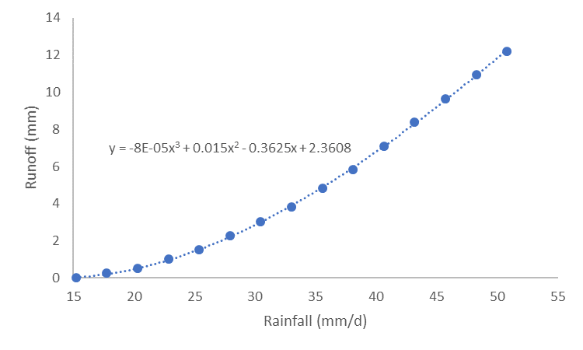
The runoff curve and the polynomial equation for the curve shown in Figure 15 are for straight row, grain crops grown in soils of ‘poor hydrologic condition’. In this equation, y = runoff (note: ‘y’ in the polynomial equation shown above corresponds to ‘Q’ in Equation 1) and x = rainfall (note: ‘x’ in the polynomial equation shown above corresponds to ‘P’ in Equation 1). The polynomial equation for the runoff curve predicts the value of runoff for any value of rainfall. The Q/P term in Equation 1 is not constant and can be calculated using the polynomial equation (some examples are shown in Table 9).
Table 9: Calculation of runoff (Q) for different rainfall values based on the polynomial equation for the runoff curve shown in Figure 10
Rainfall (mm)  (“P” from Equation 1) | Runoff (mm)  (“Q” from Equation 1) | Q/P  (for inclusion in Equation 1)
20 | 0.47 | 0.024
30 | 2.83 | 0.094
40 | 6.74 | 0.17
50 | 11.7 | 0.23
50.81 | 12.2 | 0.24
¹ This value is included for cross reference to the look-up table above (Table 8) where 50.8 mm of rainfall is predicted to have runoff of 12.2 mm, which in Table 9 is calculated from the polynomial equation.

Summary of the procedure
The procedure for: (1) developing a polynomial equation that characterises a rainfall-runoff dataset; and (2) determining the percentage of an application dose dissolved in runoff water and available to pose a potential risk through aquatic exposure, involves a series of steps that can be summarised as follows:
- Select (or adapt, as the case requires) a hydrological soil-cover complex from the USDA’s National Engineering Handbook Part 632.
- Apply the rainfall-runoff table with curve number selected (or adapted) from the USDA’s National Engineering Handbook Part 632 identified at Step 1.
- Determine the range of rainfall values and corresponding runoff values for consideration (Note: The rainfall lower limit is the rain required for runoff to commence; the rainfall upper limit must, at very least, capture the 75th percentile rainfall value). The rainfall and runoff data chosen from the USDA’s National Engineering Handbook are used to develop a rainfall-runoff dataset. Finally, a polynomial equation is fitted to the dataset using Microsoft Excel.
- As a separate exercise, substitute an individual value of rainfall (the ‘P’ term in Equation 1), the value of runoff (the ‘Q’ term in Equation 1) that corresponds to the rainfall value, and chemical-specific information such as half-life and K_{D} in Equation 1. Solving Equation 1 yields the percentage of an application dose dissolved in runoff water and available to pose a potential risk through aquatic exposure is predicted.

Appendix 2: Worked example of screening level runoff risk assessment
Screening level runoff risk assessments provide initial estimates of the risks posed by the aquatic exposure to pesticide contained in runoff that results from rainfall. The derived estimates are based on worst-case scenarios for risk determination.
Table 1 shows the soil profile with the highest runoff propensity is in Queensland where >80 per cent of topsoils contain >40 per cent clay. Table 2 shows the worst case scenario, based on the highest runoff curve number, is fallow, bare soil. Hence, the worst case composite rainfall-runoff curve is generated for Queensland under fallow, bare soil conditions. This composite curve is applied in the screening level runoff risk assessment regardless of the situation being assessed. Pesticides that pose risks estimated to be acceptable at the screening level do not require any additional risk assessment.
As described in Section 3.1, the composite rainfall-runoff curve for Queensland under fallow/bare soil conditions is CN 93. The runoff/rainfall equation for this CN is shown as:
Figure 16: Composite runoff curve for fallow, bare soil in Queensland (curve number 93)
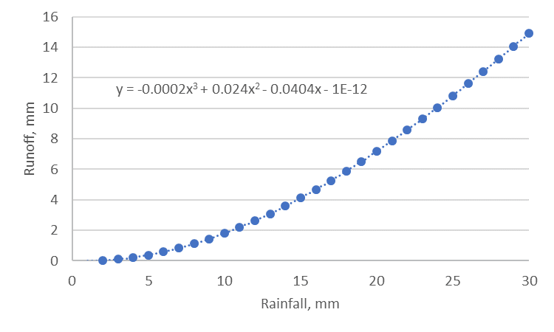
In this equation, y = runoff (mm) for a given value of x, where x = rainfall.
The screening level assessment is performed using the standard water body scenario adopted in Australian risk assessments viz. a 10 ha catchment feeds a 1 ha surface area water body with an initial depth of 10 cm. In this scenario, the rainfall value that results in the maximum receiving-water body concentration is 8 mm. At higher rainfalls, the concentration of pesticide is diluted by additional runoff.
Screening level calculations are based on this equation. The following table provides the step-wise process with the screening level runoff risk assessment for determining exposure to pesticide in runoff and the corresponding risk quotient for a hypothetical chemical.
Table 10: Stepwise calculations for determining receiving-water concentration of pesticide and risk quotient
 | Calculation (where applicable) | Parameter value
Catchment properties
Treated area |  | 10 ha
Surface water pond dimensions |  | 1 ha, 15 cm deep
Surface water initial volume | 10,000 m X 0.15 m X 1,000 L | 1,500,000 L
Chemical properties
Soil half-life (DT₅₀) |  | 20 days
Soil adsorption coefficient, Kd |  | 0.8 L/kg
Aquatic regulatory acceptable level | RAL—ecotoxicity value | 8.5 µg/L
Application rate |  | 1,000 g ac/ha
Calculating L% (Equation 1)
Rainfall value (P) |  | 8 mm (default at screening level)
Runoff (Q) | =(-0.0002*P³)+(0.024*P²)–(0.0404*P) | 1.11 mm
Q/P | =1.11 / 8 | 0.14
Slope |  | 8% (default at screening level)¹
Slope factor | =(0.02153 X slope + 0.001423 X slope²) | 0.2633
Chemical remaining available following degradation | =(-3*LN(2)/DT₅₀) | 0.901
Heterogeneity factor | Assumes half the treated area contributes to runoff | 0.5
Final loss (%) in dissolved phase | =0.14 (Q/P) * 0.2633 * 0.901 * 0.5 * (100/(1+Kd)) | 0.91
The % loss is calculated in terms of total mass of the chemical lost and distributed into the final water volume of the water body.
Total volume of runoff water (10 ha) | =1.11 mm (Q) * 10 (ha) * 10,000 (m²/ha) * 1,000 (L/m³) | 111,040 L
Total volume of receiving water | =1,500,000 (initial) + 111,040 | 1,611,040 L
Mass of chemical lost (10 ha) | =1,000 g (application rate) * 10 (ha) * (0.91/100 – % lost) * 1,000,000 (µg/g) | 91,497,199 µg
Predicted environmental concentration (PEC) | =91,497,199 µg / 1,611,040 L | 56.8 µg/L
Risk quotient | = 56.8 µg/L (PEC) / 8.5 µg/L (RAL) | 6.7 (Conclusion: risk is unacceptable)
¹ It is apparent from the 90th percentile slope obtained through the MCAS analysis that slopes can be significantly steeper in Tasmanian horticulture regions than other horticultural/pasture/turf areas in the country. At the initial screening level runoff risk assessment, the slope is fixed at 8%. This is expected to cover >90% of situations at the screening step. Horticultural, turf (golf courses) and pasture uses in Tasmania have 90th percentile slopes exceeding this value and in such cases, modelling runoff risk for Tasmania should proceed immediately to the Step 1 refinement.
The screening level runoff risk assessment outlined in Table 10 identifies an unacceptable risk. Therefore, the risk assessment should proceed to a Step 1 refinement of the runoff risk assessment.

Appendix 3: Worked example of Step 1 refinement of the runoff risk assessment
Real-world data on soil profiles and slopes are applied in the Step 1 refinement of runoff risk assessments. This level of assessment retains the assumption of a 10 ha catchment with runoff to a 1 ha pond with an initial water depth of 15 cm. The calculations for these components are the same as those shown in Appendix 2 and are not repeated here.
Demonstrated below is a spatial assessment for the same pesticide and use pattern as described in Appendix 1. However, two states—Queensland and Victoria—are now considered. A curve number of 93 still applies for Queensland. Therefore, the equation for runoff (Q) is that shown in Appendix 2, Figure 16.
The soil profile for Victoria (refer to Table 1: Soil composition according to hydrologic soil group) and the USDA curve numbers for a fallow, bare soil cover complex (refer to Table 2: Alignment of USDA Cover Type and HSG rainfall-runoff indexes with Australian agricultural practices) are applied. The methodology described in Appendix 1 is then used to calculate a final curve number of 87 (rounded down from 87.25) and generate a composite runoff curve for Victoria. The polynomial equation and curve are as follows:
Figure 17: Composite runoff curve (curve number 87) for fallow, bare soil in Victoria
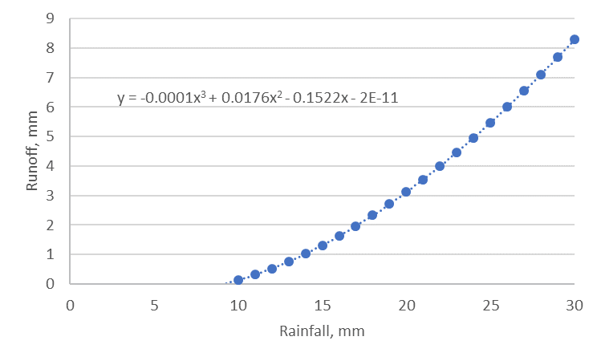
Victorian soils have a lower clay content than Queensland soils and therefore a lower curve number. Consequently, a greater rainfall value is required prior to commencement of runoff in Victoria compared to Queensland. The rainfall value that corresponds to the peak pesticide concentration in the standard water body is determined for inclusion in the calculations. This calculation is carried out at the point when the value of Q/P is maximal. This occurs for Victoria at 16 mm of rainfall and for Queensland at 8 mm of rainfall.
A slopes analysis in dryland growing regions of Queensland and Victoria (described in Section 3.2) yielded 90th percentile slopes of 1.97 per cent and 1.18 per cent, respectively. Applying the different rainfall and slope values for the two states and following the methodology in Appendix 2 for each state results in the following outcomes for Step 1 refinement of the runoff risk assessment.
Table 11: Step 1 refinements of the runoff risk assessment—spatially different outcomes in Queensland and Victoria attributed to different soil types and slopes
State | Rainfall (mm) | Slope (%) | Runoff (mm) | L% | PEC (µg/L) | Risk Quotient
Queensland | 8 | 1.97 | 1.11 | 0.17 | 10.34 | 1.22
Victoria | 16 | 1.18 | 1.66 | 0.07 | 4.27 | 0.50
At this first step of refinement, receiving-water concentrations are decreased significantly from the screening level runoff risk assessment that takes slopes and soil types into account. The risk posed by the aquatic exposure to pesticide contained in runoff from rainfall in Victoria is now demonstrated to be acceptable. By contrast, the risk in Queensland remains unacceptable; however, the risk is significantly reduced when compared to the screening level runoff risk assessment outcomes described in Appendix 2.

Appendix 4: Additional discussion of the Step 2 refinement of the runoff risk assessment (including instream analysis)
Instream analyses are critically important components of a Step 2 refinement of the runoff risk assessment and such analyses require a lot of data to conduct. The APVMA has published the dryland streamflow data, which provides a starting point to undertake this level of assessment. The streamflow data needs to be amended for baseflow, which in turn requires long-term rainfall data. In addition, the streamflow data and rainfall data need to be separated into relevant time periods – typically seasons or months depending on the situation being assessed.
In order to demonstrate the approach, the APVMA accessed the necessary information through a third party. The pesticide and application rate discussed in this Appendix are identical to those assessed in Appendices 2 and 3. It is also noted in Appendix 3 that under Queensland conditions, the risk from aquatic exposure to the pesticide is unacceptable. The risk, in this instance, was estimated from a Step 1 refinement of the runoff risk assessment.
Rainfall data, which comprised approximately 220,000 daily rainfall values grouped by season, was collected from 21 weather stations in the dryland growing regions of Queensland. Based on the background catchment and known soil profile for Queensland, the rainfall required for runoff to commence was predicted to be 9 mm. The 25th and 75th percentiles of seasonal rainfall values ≥9 mm for each weather station were then derived. Finally, the 90th percentile of the range of 25th and 75th percentile values were calculated for modelling purposes.
Daily streamflow data was available for 136 monitoring stations, and based on probability of seasonal rainfall, 544 individual baseflow indexes were calculated prior to determining flow rate distributions. The 25th and 75th percentile streamflow rates, which accounted for the baseflow rates, were then determined for each monitoring station.
A slopes analysis following the methodology in Section 3.2 was conducted and demonstrated a mean slope determination of 0.86 per cent for dryland growing regions in Queensland.
Predicted pesticide losses (L%) from the treated field were calculated by substituting the values of the mean slope and refined rainfall in Equation 1: Simplified formula for indirect loadings caused by runoff. Theoretical instream concentrations for each assessed streamflow percentile and season were then calculated at the time immediately after the edge-of-field runoff containing pesticide had distributed into the stream (the procedure is described in Section 4.3). The aquatic Regulatory Acceptable Level (RAL) for each distribution was compared with the predicted instream concentration. For those situations in which the RAL exceeded the predicted instream concentration, biodiversity was considered to be protected. The following table shows the outcomes of the analysis:
Table 12: Dryland cropping for a fallow, bare soil scenario in Queensland¹
Season | Percent streamflow | Rainfall (mm/d) | L% | Percent receiving waters protected
Autumn | 25  75 | 12.9  30.6 | 0.0512  0.1021 | 94.4  >99
Spring | 25  75 | 12.6  30.1 | 0.0502  0.1010 | 97.4  >99
Summer | 25  75 | 13.1  30.7 | 0.0519  0.1023 | 98.4  >99
Winter | 25  75 | 12.7  29.0 | 0.0505  0.0985 | 91.2  >99
¹ Pesticide was applied once at a rate of 1,000 g active constituent per hectare.
The lowest level of protection occurs in winter, which is a low rainfall season in Queensland. In this scenario, biodiversity was protected in 91.2 per cent of receiving-waters. The distribution of the 25th percentile streamflow data in the winter months in Queensland is shown in Figure 18.
Figure 18: Distribution of theoretical instream concentrations
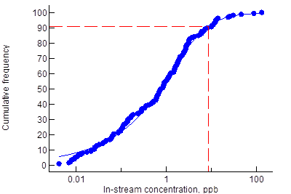
The curve shown In Figure 18 was generated from 25th percentile streamflow data in the winter months in Queensland. The vertical dashed line represents 8.5 µg/L, which is the maximum permitted concentration of pesticide. The horizontal dashed line represents the percentage of receiving-waters that are protected.

Appendix 5: Baseflow calculations
In the methodologies described here and in the European FOCUS stream scenarios, an important component of the stream analysis relates to baseflow. Failing to take baseflow into account requires estimates to be based on streamflow rate percentiles derived from cumulative frequency distribution curves for the total dataset. Moreover, instream concentrations will be over-estimated when increased flow caused by rainfall runoff is not treated as an additional flow rate. In this scenario, the rainfall value used for predicting runoff concentration would remain unchanged.
Parameters quantifying the catchment ‘Baseflow Index’ (BFI) are needed for deriving a baseflow component of the hydrological flows feeding the surface water bodies in the FOCUS scenarios. The BFI quantifies the fraction of long-term total flow in a catchment that is attributed to baseflow. In the European scenarios, this parameter was derived from an estimated soil hydrological class at each representative field site. Associated with estimated soil hydrological classes are a set of empirically-derived coefficients that describe streamflow characteristics. BFI values ranging from 0.17 to 0.79, based on soil hydrological characteristics, were adopted for each of the FOCUS surface water scenarios.
A classification tool of this kind is not available in Australia. A conservative approach to calculating an individual BFI for each monitoring station in each season is applied in Australia. For the analysis, positive flow is considered to be >0.001 m/s (~0.09 km/h) and for the standard stream of 3 m wide and 15 cm deep, this equates to a flow rate of volume of approximately 1.15 L/s (0.1 ML/d). This low flow rate is used as the positive flow cut-off for reducing possible inconsistencies when measuring low flow conditions at different monitoring stations.
All long-term monitoring flow data is grouped by season and the time (expressed as a per cent) of positive flow determined.
The probability of rainfall for each region is obtained by taking the lower 10th percentile of rainfall probability for the season of interest. The outcome probability is for any rainfall, not only rainfall that could generate runoff. The latter will be highly variable and depend on other factors such as soil type and slopes within a particular catchment.
In this manner, a unique BFI for each monitoring station by season is calculated as the difference between the time (expressed as a per cent) in positive low rainfall and the probability of any rainfall. In many cases, positive flow periods for streams occur less frequently than rain periods. This is particularly the case in drier seasons, which is not surprising given that the rainfall likelihood is for any rainfall, not only rainfall resulting in runoff. In these instances, the BFI was set at 0, and means that any flow in these systems is assumed to be the result of quick-flow only. This demonstrates the conservatism of the approach.
The BFI values applied in the assessment of streamflow data are summarised in Table 13.
Table 13: Summary of Baseflow Index (BFI) values for dryland cropping regions
Model | Slope (%) | Summer | Autumn | Winter | Spring
New South Wales | Minimum BFI  Maximum BFI  Median BFI  10th percentile | 0.00  0.82  0.79  0.34 | 0.00  0.82  0.79  0.35 | 0.00  0.83  0.82  0.66 | 0.00  0.83  0.80  0.49
Victoria | Minimum BFI  Maximum BFI  Median BFI  10th percentile | 0.00  0.89  0.54  0.00 | 0.00  0.84  0.62  0.01 | 0.00  0.72  0.65  0.09 | 0.00  0.79  0.64  0.07
Queensland | Minimum BFI  Maximum BFI  Median BFI  10th percentile | 0.00  0.87  0.66  0.39 | 0.00  0.86  0.54  0.18 | 0.00  0.87  0.50  0.09 | 0.00  0.86  0.50  0.21
Western Australia | Minimum BFI  Maximum BFI  Median BFI  10th percentile | 0.00  0.93  0.25  0.00 | 0.00  0.85  0.58  0.00 | 0.00  0.67  0.66  0.04 | 0.00  0.85  0.45  0.00

Abbreviations
∆T | Duration of heavy rain event in seconds
BFI | Baseflow index
DoEE | Department of the Environment and Energy
DT₅₀ | Half-life of an active ingredient, expressed as days
DT_{50soil} | Half-life of an active ingredient in soil, expressed as days
f1 | Slope factor
f2 | Influence of plant interception
f3 | Influence of a densely covered buffer zone
FOCUS | Forum of the Coordination for Pesticide Fate Models and Their Use
HSG | Hydrologic Soil Group
Kd | Pesticide soil-sorption coefficient
L_{%runoff} | Percentage of (pesticide) application dose dissolved and available in runoff water
MCAS-S | Multi-Criteria Analysis Shell for Spatial Decision Support
P | Daily precipitation, expressed as mm/day
Pa | Chemical (pesticide) applied to the simulation area, expressed as µg
Pc | Simulated mean pesticide instream concentration, expressed as µg/L
Q | Runoff volume, expressed as mm/day
Qstream | Peak streamflow during heavy rain events, expressed as L/s
SCEW | Standing Council of Environment and Water
SFIL | Simplified formula for indirect loadings
RAL | Regulatory acceptable level

Glossary
Background catchment | A catchment with defined land cover attributes that is used to determine an appropriate rainfall value required for runoff to commence in different states and regions.
Baseflow | Baseflow is the portion of the streamflow that is sustained between precipitation events, and is not the result of rainfall runoff.
Baseflow index | Baseflow index quantifies the fraction of long-term, total flow representing baseflow.
Composite rainfall-runoff curve | A curve describing the relationship of runoff to rainfall calculated by weighting surface coverage factors such as land use and vegetation, with hydrologic soil group data.
Cumulative frequency distribution | Cumulative frequency of occurrence of values of a phenomenon.
Ecotoxicity end-point | Defined end-point usually based on EC50, LC50 or NOAEC, expressed as a concentration.
Edge-of-field | Pesticide runoff at the edge of a field as a consequence of rainfall runoff, expressed as a concentration.
Lentic water body | Lentic water bodies include freshwater lakes, saline lakes, ponds, marshes, swamps and billabongs. They may be temporary or permanent in nature. Artificial lentic water bodies include large water infrastructure dams, weirs, farm dams and other storage reservoirs.
No-till | A farming method for growing crops or pasture based on minimal disturbance of the soil through tillage (mechanical agitation). Usually involves leaving crop stubble as ground cover.
Probability density function | A function of a continuous random variable whose integral across an interval gives the probability that the value of the variable lies within the same interval.
Qstream | Peak streamflow during heavy rain, expressed as L/sec.
Quick flow | Stream-flow due to rainfall runoff.
Rainfall-runoff index | A label representing a relationship between rainfall and runoff with higher numbers indicating more runoff than lower numbers.
Regulatory acceptable level | The ecotoxicity level considered to be acceptable and in runoff risk assessments, the maximum receiving-water concentration not expected to cause undue harm to aquatic organisms.
Risk quotient | The ratio of an estimated environmental concentration with a relevant ecotoxicity end-point. Quotients of 1.00 or above generally indicate unacceptable risk.
Standard water body | A model water body comprising a 1 ha water body that is 15 cm deep and has a 10 ha catchment draining into it.

References
Berenzen N, Lentzen-Godding A, Probst M, Schulz H, Schulz R and Liess M, 2005, A comparison of predicted and measured levels of runoff-related pesticide concentrations in small lowland streams on a landscape level, Chemosphere Vol 58 pp 683–691.
FOCUS, 2001, FOCUS Surface Water Scenarios in the EU Evaluation Process under 91/414/EEC. Report of the FOCUS Working Group on Surface Water Scenarios, available at esdac.jrc.ec.europa.eu/public_path/projects_data/focus/sw/docs/FOCUS_SWS_Final_Report.doc.
FOCUS, 2011, Generic Guidance for Tier one FOCUS Ground Water Assessments, available at esdac.jrc.ec.europa.eu/public_path/projects_data/focus/gw/NewDocs/GenericGuidance2_2.pdf.
FOCUS, 2011a, Generic guidance for FOCUS surface water Scenarios, Version 1.0, January 2011, available at esdac.jrc.ec.europa.eu/public_path/projects_data/focus/sw/docs/Generic%20FOCUS_SWS_1.2.pdf.
Freebairn D, 2004, Some observations on the role of soil conservation structures and conservation, Journal of the Australian Association of Natural Resource Management, Vol 7(1): 8–13.
OECD, 2000, Report of the OECD Pesticide Aquatic Risk Indicators Expert Group, Braunschweig, Germany, OECD: 14–21, available at oecd.org/chemicalsafety/pesticides-biocides/2078654.pdf.
Probst M, Berenzen N, Lentzen-Godding A and Schulz R, 2005, Scenario-based simulation of run-off-related pesticide entries into small streams on a landscape level. Ecotoxicology and Environmental Safety. Vol 62(2) pp145-159.
SCEW, 2009, Environmental Risk-assessment Guidance Manual for agricultural and veterinary chemicals, (Formerly) Standing Council on Environment and Water, February 2009, available at nepc.gov.au/system/files/resources/bffdc9e9-7004-4de9-b94f-b758140dbc8c/files/cmgt-nchem-eragm-agricultural-and-veterinary-chemicals-200902.pdf.
Soilquality.org.au, 2015, Benefits of retaining stubble—Queensland, available at s3.amazonaws.com/soilquality-production/fact_sheets/56/original/Benefits_of_retaining_stubble_Qld_for_web_270812.pdf?1346127089.
USDA, 2002, National Engineering Handbook, Land Use and Treatment Classes, Part 630, Chapter 8, Natural Resources Conservation Service, United States Department of Agriculture, available at irrigationtoolbox.com/NEH/Part630_Hydrology/neh630-ch08.pdf.
USDA, 2004a, National Engineering Handbook, Hydrologic Soil-Cover Complexes, Part 630, Chapter 9, Natural Resources Conservation Service, United States Department of Agriculture, available at irrigationtoolbox.com/NEH/Part630_Hydrology/H_210_630_09.pdf.
USDA, 2004b, National Engineering Handbook, Estimation of Direct Runoff from Storm Rainfall, Part 630, Chapter 10, Natural Resources Conservation Service, United States Department of Agriculture, available at irrigationtoolbox.com/NEH/Part630_Hydrology/H_210_630_10.pdf.

A risk quotient is the ratio of an estimated environmental concentration to a relevant ecotoxicity end-point.
A level of concern is dependent on the acute or chronic nature of the studies. If the risk quotient is greater than or equal to 0.1 (for acute toxicity data) or 1.0 (for chronic toxicity data), the risk is deemed unacceptable. These default values may be decreased when considering protected or sensitive ecosystems.
The APVMA assumes 50 per cent of intercepted chemical remains available for wash off, and this assumption is maintained unless data can demonstrate otherwise.
River flow percentiles are defined as the xth percentile being equal to, or greater than, x percent of the discharge values recorded on the particular day of the year, during all years that measurements were made.
The APVMA assumes 50 per cent of intercepted chemical remains available for wash off, and this assumption is maintained unless data can demonstrate otherwise.

